Compiler Design Notes

CS3005D

Vineeth Paleeri and Varun Rajan

|  |
| --- |
|  |

# 1. Introduction

11.01.2021

11:15-x:xx

## 1.1. Course Objective

**To introduce the principles and techniques of programming language translation.**

## 1.2. On Asking Questions in Class…

* Any questions, please wait until the class ends at 45 minutes, the remaining 15 minutes are reserved for questions, so in the limited first part, sir will focus on covering his content.
* **Ask doubts.** If not clear, raise your hand as soon as possible, or even by mail.
* We are permitted to ask for doubt session classes, face-to-face if you feel the need,

|  |
| --- |
|  |

## 1.3. On Tutorial Sessions…

* They will try to cover such sessions as and when required.

## 1.4. References

|  |
| --- |
|  |

**Note:** Make sure you use the versions specified. Very important.

* Appel and Palsberg is the more important one, Aho is somewhat unnecessary and contains not much additional information.
* Aho should be online free somewhere.
* Keep these two references handy.

## 1.5. Evaluation Policy

* In the middle of every ~~session~~ segment, we will have one of the quizzes.
  + Total 3 quizzes, 10 marks each.
  + In the middle of the 3 segments, once before T1, once b/w T1 and T2, and once b/w T2 and Endsems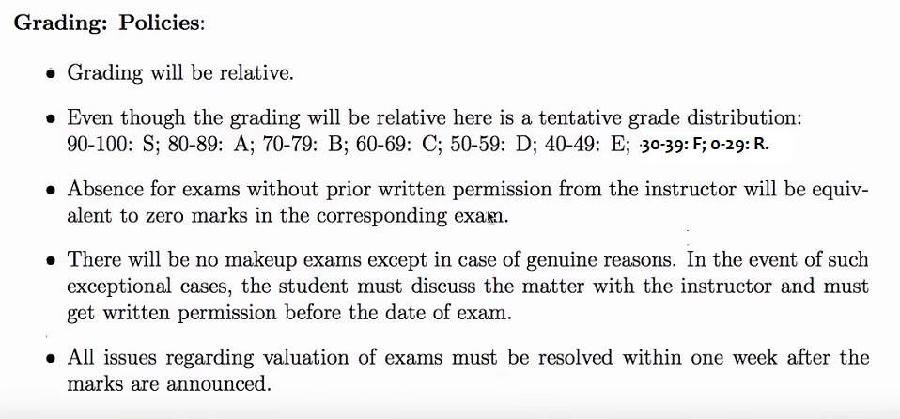

## 1.6. Course Schedule

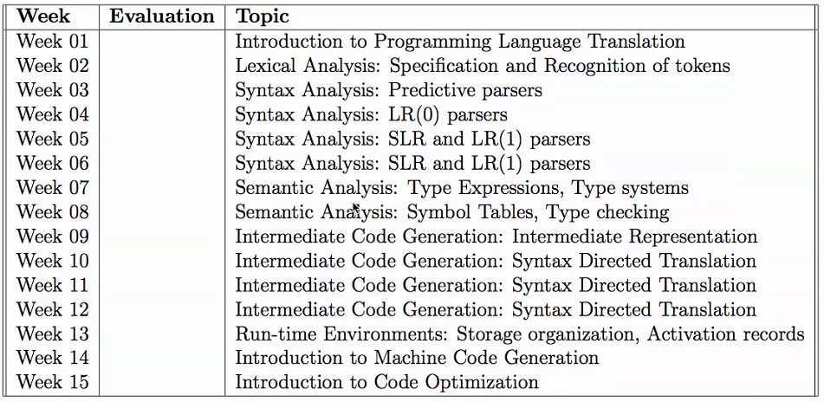

# 2. Intro to Programming Language Translation

## 2.1. Writing a Compiler - Basics

12.01.2021

8-9 am

* **‘Compiling’** refers to the translation of a high language program into machine language or some intermediate language.

|  |
| --- |
| **Note:** In Java, programs are not compiled into executable files; they are compiled into bytecode, which the JVM (Java Virtual Machine) then executes at runtime. |

* **To write a compiler (given its language and input/outputs), what else must be given?**
  + A language is defined by its **syntax/semantics**, therefore those two are necessary.
  + **‘Machine instruction set’** is required on the architecture side.
  + E.g.;

|  |  |
| --- | --- |
| DD-DD-DDDD | Syntax (Format/Grammar of the language) “**Syntax** is the arrangement of elements and attributes to create well-formed documents.” |

(Eg, **01-02-2021** vs **01-02-1**)

|  |  |
| --- | --- |
| DD-MM-YYYY Where each given number is valid (ie, DD<31, MM<12, etc) | Semantics (Meaning of the language)  **“Semantics** is concerned with meaning.” |

(Eg, **01-02-2021** vs **32-02-2021**)

## 2.2. Language of Binary Numbers

**Assigning Meaning/Value:**

Let us define an attribute ‘val’ for every N, such that for a given N,

|  |  |
| --- | --- |
| **Syntax** | **Semantics** |
| N : : = 0 | N.val = 0 |
| N : : = 1 | N.val = 1 |
| N : : = N,0 | N.val = N1.val*2 + 0 |
| N : : = N,1 | N.val = N1.val*2 + 1 |



### 2.2.1. Pragmatics

Another essential component of a language, alongside syntax and semantics.

Pragmatics is a subfield of linguistics and semiotics that studies how context contributes to meaning

### 2.2.2. What is a Compiler

* Performs conversion of the source language (usually a high-level language) into some intermediate language.
  + The intermediate language may be machine language, assembly language, byte code, or some other language. Usually low-level, dependent on the architecture of the target machine, ie, on the **machine instruction set**.
  + Note: For Java, the interpreted language is Byte Code, which is actually machine-independent.

#### 2.2.2.1. Context of a Compiler

Take an example of a compiler that converts to assembly language.

* The assembler takes the thus produced assembly language and gives ‘relocatable machine code’.
  + Relocatable=> can be taken to any place in the memory, and thus its execution address can be changed.
* This goes to the linker/loader, which takes the relocatable machine code, consults a library (check??), and finally gives the object code, which can actually be run.

# 

# 3. Translation of an Assignment Statement

15.1.2021

2-2:45 pm

**References:** Aho t/b, pages 1-12.

A compiler has 2 parts: analysis{breaks into constituent parts and imposes a grammatical structure} and synthesis {constructs the desired target pgm }.

## 3.1. Entire Process of a Compiler: phases of a compiler

### 3.1.1. Syntax Analyser

#### 3.1.1.0.1. Lexical Analysis

* Looks at the program as just a sequence of characters /file.
* Reads characters one-by-one
  + Tries to identify characters that form logical units (identifiers, assignment operators, semicolons, logical operators, integers, constants, etc).
  + Produces logical units or **tokens**; sequence of token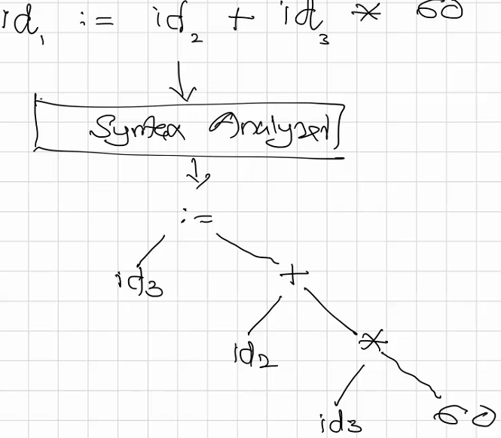
* Passes this sequence of tokens forward to the Syntax Analyzer.

#### 3.1.1.0.2. Syntax Analysis

* Given the sequence of tokens, it checks that they fulfill the relevant syntax to that language/machine.
* Checks whether the syntax is correct, and passes code to Semantics Analyser.
* Syntax analyser constructs a parse tree
* Checks based on the grammar.

.

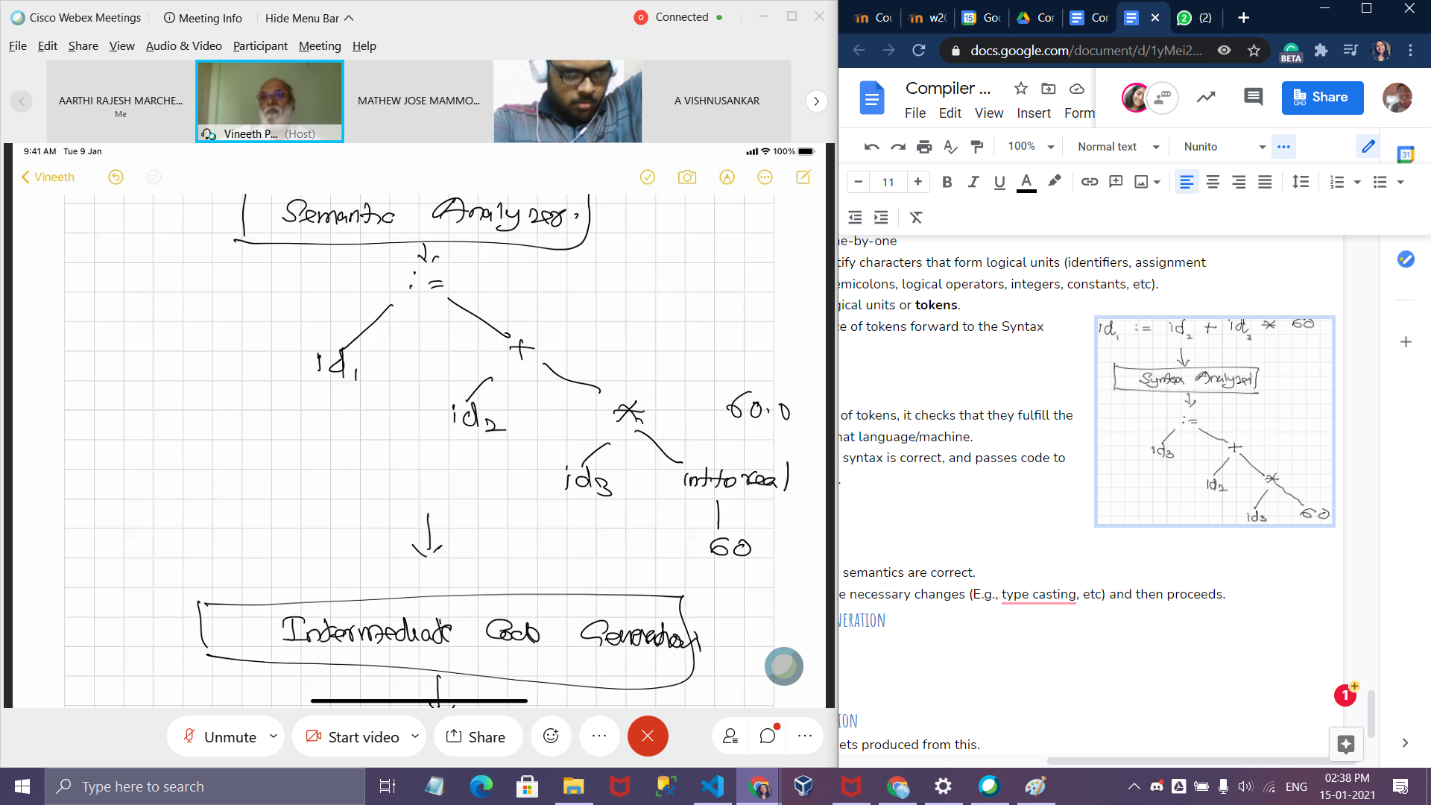

### 3.1.2. Semantics Analyser

* Checks whether the semantics are correct.
* If not, it performs the necessary changes (E.g., type casting, etc) and then proceeds.
* Semantic error: multiplication of a float number with an integer, In c: int 64 is converted to float

### 3.1.3. Intermediate code generation (backend starts here) ; before this is the front end.

* Traverse the tree and save the intermediate values. **FROM THE BOTTOM** of the tree.

Example: t1 = int to real 60

t2 = t1 * id 1;

t3 = id2 + t2;

Id1 = t3;

t1, t2 … are compiler generated temporary variables for every internal node.

By this time, we will have the basic machine instructions.

* Note: this intermediate code is machine-independent and thus improves portability (intentional, or unintentional bonus?)

**“** In the process of translating a source program into target code, a compiler may construct one or more intermediate representations, which can have a variety of forms. Syntax trees are a form of intermediate representation; they are commonly used during syntax and semantic analysis. **”**

**- Aho-Lam-Sethi-Ullman**

* After semantic analysis, the compiler generates a low-level, machine language-like intermediate language that functions as a program for an abstract machine.
  + The most important aspects of this intermediate language are its ease of production, and ease with which it is translated into the final machine language.
* There are a few methods of representing intermediate code.
  + Syntax trees
  + 3-address codes( This consists of 3 operands per instruction ; each operand = register) : this is the output This is used most of the time
  + Postfix Notation.

3-address codes: fix the order in which operations are to be done, might have less than 3

* We will see more about it in our next class.

### Class 3; 18-01-2021

### 

### 

### 3.1.4. Code Optimization

* This attempts to improve the intermediate code so that better target code will result.

Shorter code / less power / faster = better

* The intofloat can be eliminated by replacing 60 by 60.0
* It must be semantically the same

Example:

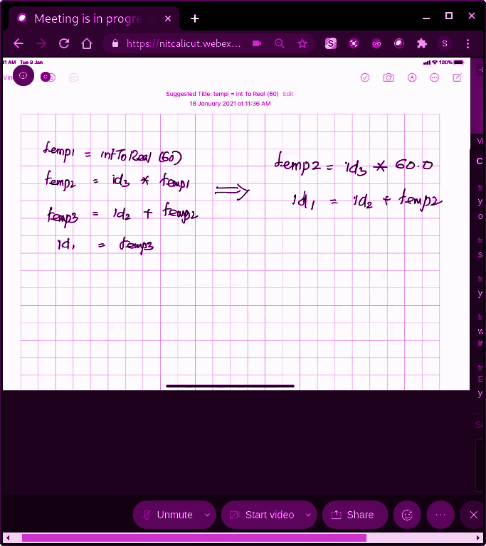

.

## 3.1.5. Machine Code Generation

Input : intermediate code

Output = target language

Registers/ Memory locations are selected for each variable.

Then intermediate instructions are translated into sequences of machine instructions that perform the same task

Main aspect is the judicial assignment of registers to hold variables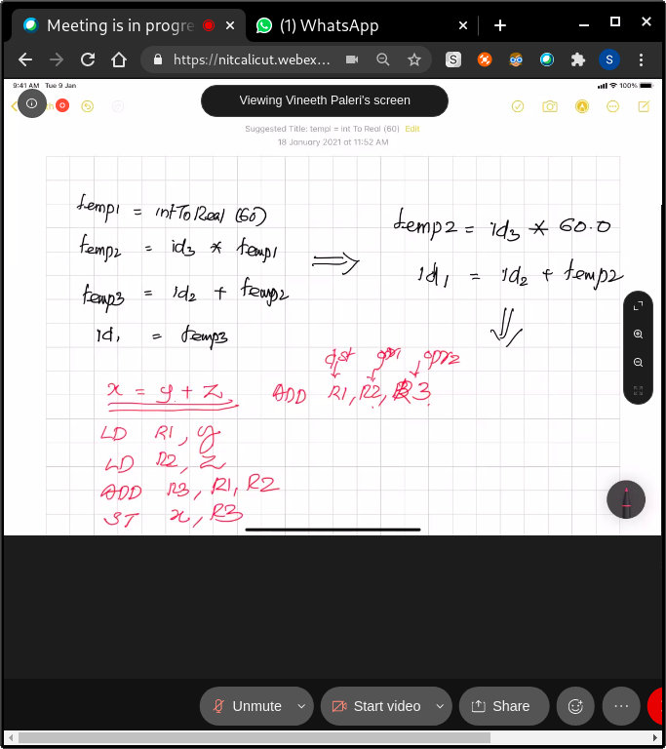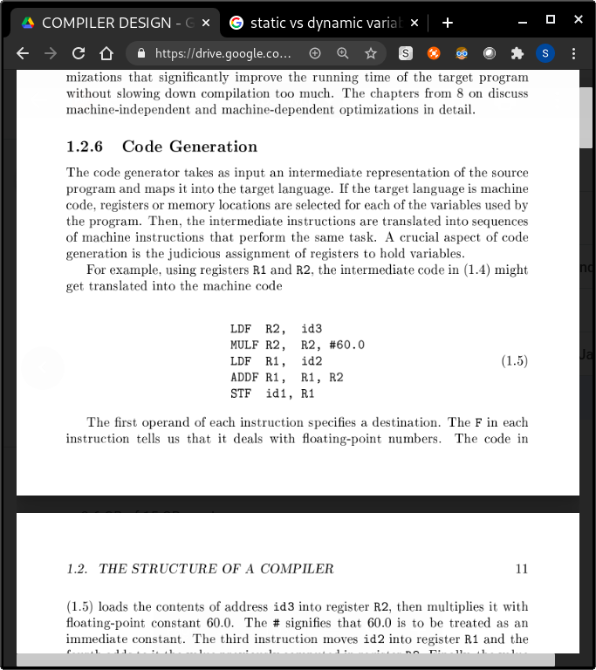

# = immediate constant; This is tbk

Sir’s implementation: 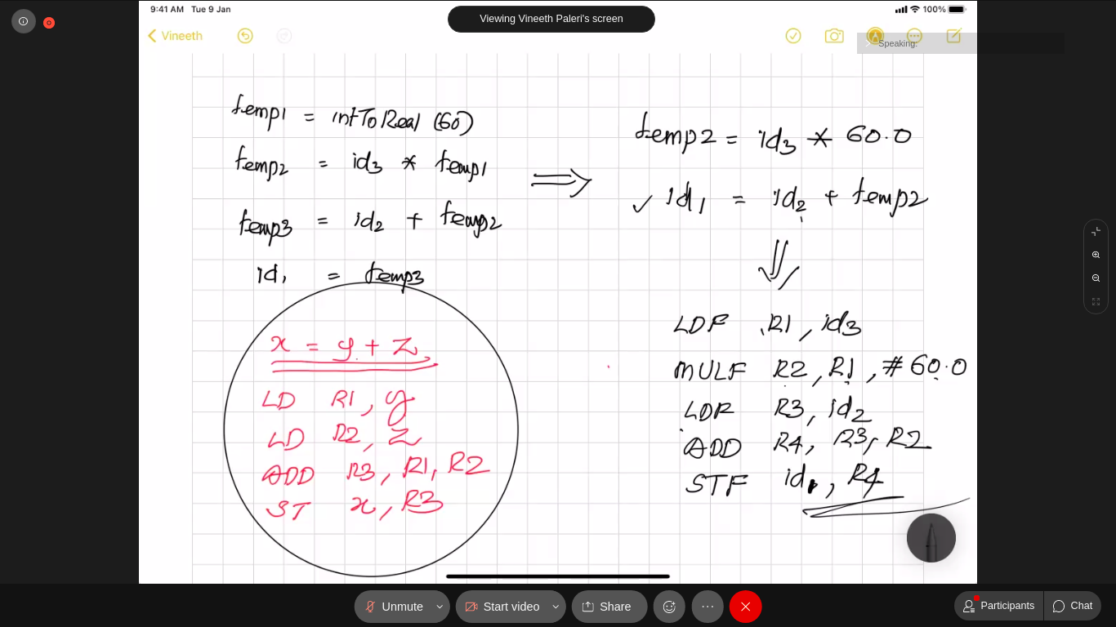

Finally, Machine Code gets produced from this.

There will be a symbol table which contains the information about the declarations(name, type) in the first phase about the identifiers .

### 

### 

### 

### 3.1.6. SYMBOL TABLE MANAGEMENT

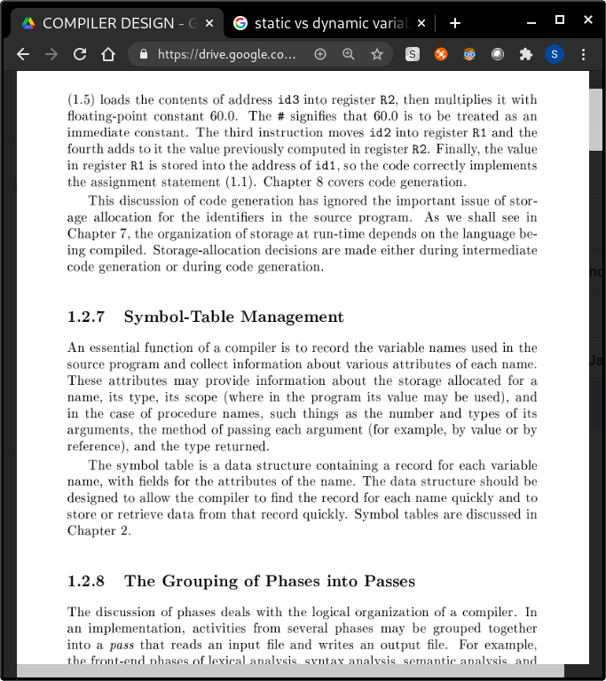

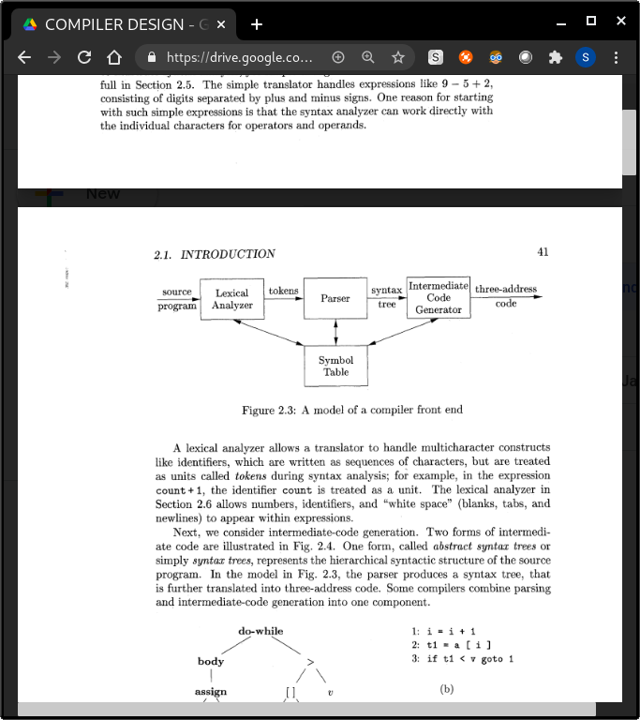

### Class 4 : 19 - 01 - 2021

# 

# Lexical analysis:(subtask of syntax analysis)

A lexical analyser allows a translator to handle multi character constructs like identifiers, which are written as sequence of characters, but are treated as units during syntax analysis ; groups characters into meaningful sequences called lexemes. Each lexem has a token.

* Simplicity : separating lexical and syntactic stuff leads to cleaner codes Compiler efficiency is improved. A separate lexical analyzer allows us to apply specialized techniques that serve only the lexical task, not the job of parsing. In addition, specialized buffering techniques for reading input characters can speed up the compiler significantly. Portability is also increased, input device specific peculiarities can be restricted to the lexical analyser.

## Tasks in lexical analysis: token = <token_name, attribute_name>

* Identify the tokens to be found out using the grammar ; “Specify” and recognise
* Error messages
* Spelling errors
* Exceeding length of identifier
* Illegal characters
* Ex: printf(“dfk”); $ or This is a comment */
* Eliminate tokens: white spaces : tab : blank spaces and newlines
* Tokens are: Identifier ; Separator ; Keyword ; Operator ; Constants / literals ; Special characters

## Step 1 : Identification of tokens

E :: = id (an identifier can be an expression)

E ::= num (or num)

E ::= E1 + E2

E ::= E1*E2

### DEfinition of grammars

G = <N, T, P, S>

1. **N = Non terminals**

A set of nonterminals, sometimes called "syntactic variables." Each non-terminal represents a set of strings of terminals, in a manner we shall describe.

1. **T = Terminals**

A set of terminal symbols, sometimes referred to as "tokens." The terminals are the elementary symbols of the language defined by the grammar.

1. **P = Productions**

A set of productions, where each production consists of a nonterminal, called the head or left side of the production, an arrow, and a sequence of terminals and/or nonterminals, called the body or right side of the production. The intuitive intent of a production is to specify one of the written forms of a construct; if the head nonterminal represents a construct, then

the body represents a written form of the construct.

1. **S = Start symbols**

A designation of one of the nonterminals as the start symbol.

N = {E}

T = {id, num, +, *}

### Attributes for tokens - describes the lexemes

* For ID : the location at which it is first found (in case an error message about that identifier must be issued) - is kept in the symbol table. Thus, the appropriate attribute value for an identifier is a pointer to the symbol-table entry for that identifier.

***Example***” E = M * C ** 2

Can be written as a sequence of pairs

<id, pointer to symbol-table entry for E>

< assign-op >

<id, pointer to symbol-table entry for M>

<mult -op>

<id, pointer to symbol-table entry for C>

<exp-op>

<number , integer value 2>

For operators, punctuations and keywords, no need of attribute value

Number has integer value as an attribute; id has the pointer to the symbol table.

Ex: printf(“i = %d, & i = %x”, i , &d); the tokens are: printf, ( , “i = %d, & i = %x” , , , i, &, i, ), ;

## Step 2. Specification of tokens: (revise re?)

Represented by regular expressions

**Union** : (r)|(s) is a regular expression denoting L(r) U L(s)

**Concatenation** : (r)(s) is a regular expression denoting L(r)L(s)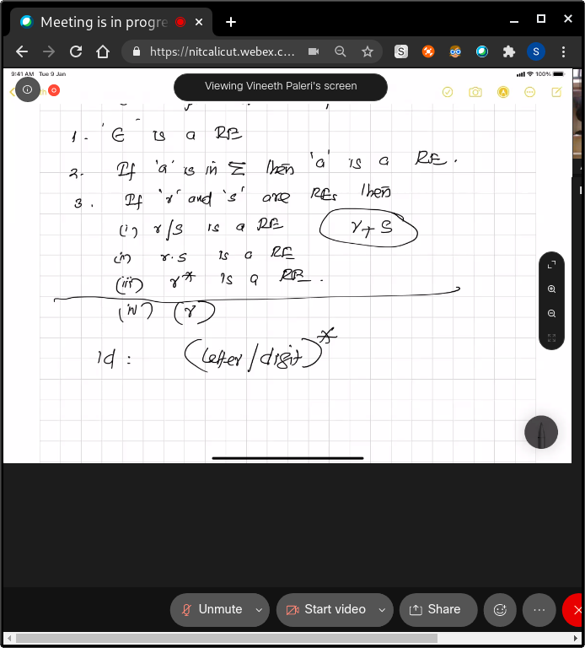

**Kleene closure** : (r)* is a regular expression denoting (L(r))*

(r) is a regular expression denoting L(r)

Last statement removes the need to use ( ) everywhere, will learn about precedence in the next class

* By specifying the precedence, we can get rid of the parentheses.
* Higher precedence = gets parentheses
* Associativity matters;
* A = b = c; = is right associative. First b = c; then the value is given to a

## Regular definitions: Generalised regex

(ss from the class)

We use Regular Expressions to specify the tokens.

For notational convenience, we may wish to give names to certain regular ex-

pressions and use those names in subsequent expressions, as if the names were

themselves symbols. If C is an alphabet of basic symbols, then a regular defi-

nition is a sequence of definitions of the form

**where:**

1. Each di is a new symbol, not in C and not the same as any other of the

di's, and

1. Each ri is a regular expression over the alphabet C U {dl, d 2 , . . . , di-l).

d1 -> r1

d2 -> r2

.

.

.

.

di ->ri

Where a rn is defined using Σ ∪ {d1,d2,d3,...dn-1}

Letter ->a|b|c|d|e|f|g|h|i|j|k|l|m|n|o|p|q|r|s|t|u|v|w|x|y|z

Digit -> 1|2|3|4|5|6|7|8|9|0

Identifier -> letter(letter|digit)*

Number -> digit(digit)*

1. “...” is not a part of the reg definition. Keep everything
2. Can't use commas
3. These are just assumptions
4. Each di is a new symbol now in Σ
5. Each ri is a regular expression over the alphabet Σ U {d1 , d 2 , . . . , d i-1).
6. Use digit + instead. That works too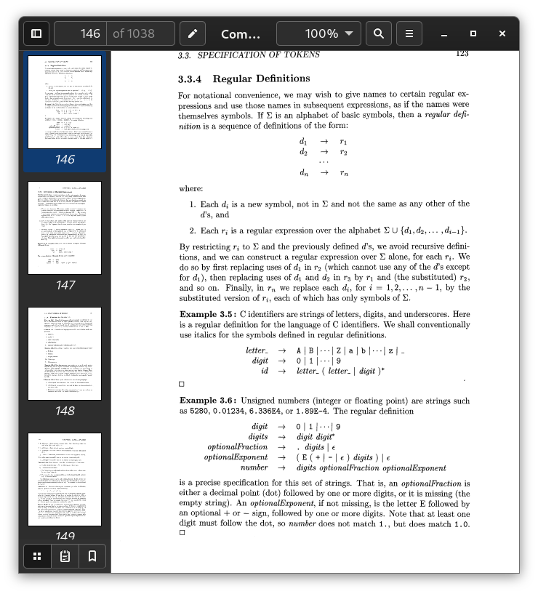

Specify and recognise

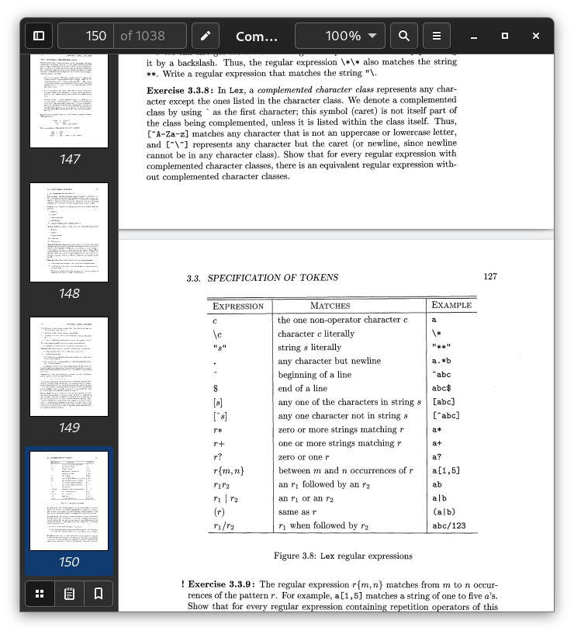

## Step 3.RECOGNISE TOKENS: (revise re?)

* Given the sequence of tokens, we need to recognise the tokens
* Every regular expression can be represented as a DFA
* Convert that to DFA

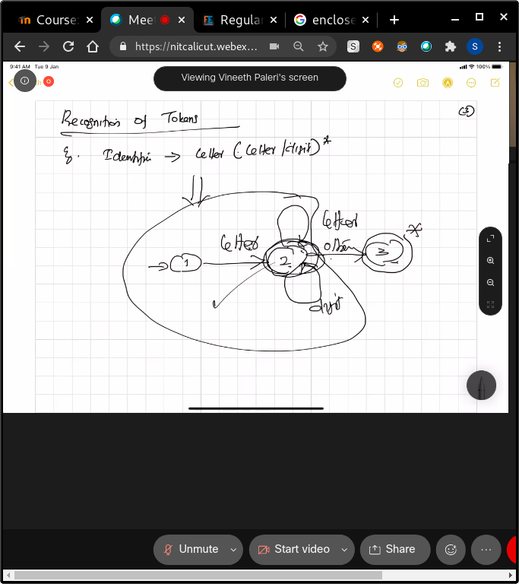

* Every token -> regex -> reg automaton
* Take one automaton. Check if it matches the first token, If it doesn't, take another one.
* Therefore the compiler sees the source code token by token and matches each token with the dfs we have. We check until the token is accepted by one of the dfas. It might not be accepted by any DFAs too. If there is a character not recognised, it just skips it and goes to the next token( last step of the dfa = go back one state and accept the token ) **longest match is taken**
* **Reserved keywords are first checked and then the rest of the DFAs are run.**
* Example: 123 = 5 +6

Tokens = 123, =, 5, 6; num, assignop, num, addop , num

No errors here

The last stage in the dfa represents the separator

23f = 23 is num, f is an id

* Recognises a “ “ but doesn't output

#### Lecture - 7

#### 22 - jan

Recognition of Tokens, DFA, Transition Diagrams.

Reference: ALSU, Section 3.4

we must study how to take the patterns for all the needed tokens

and build a piece of code that examines the input string and finds a prefix that

is a lexeme matching one of the patterns

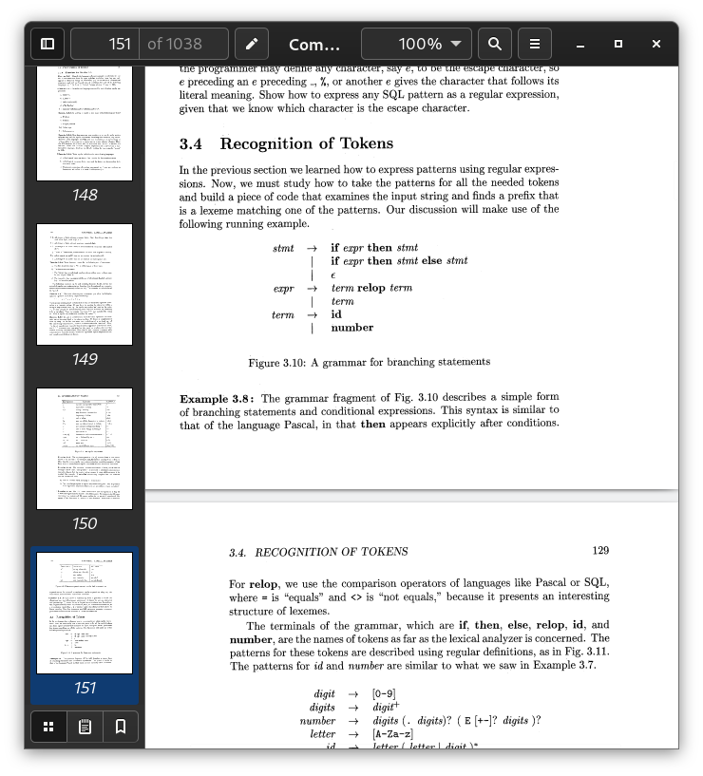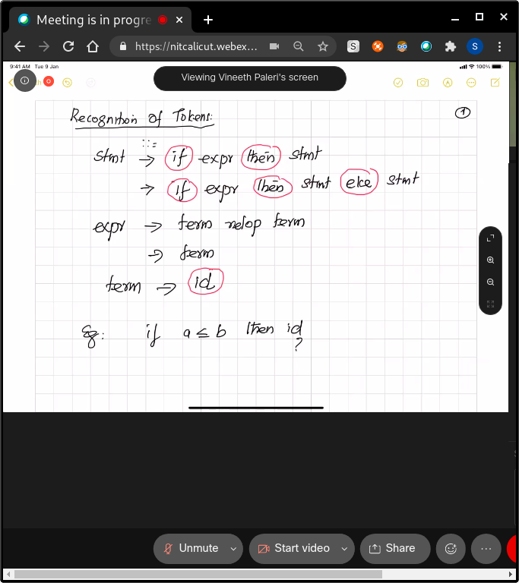

RELOP = relational operator

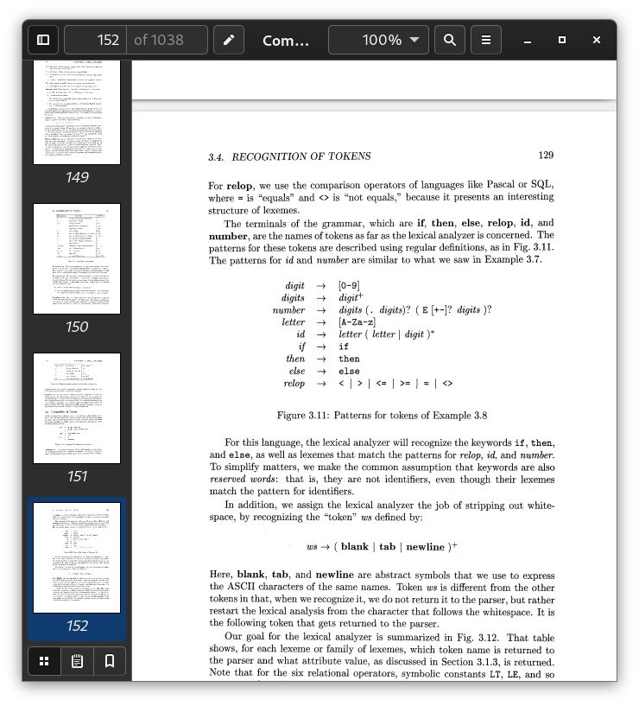

w s -+ ( blank I tab( newline )+

* The lexical analyzer will recognize the keywords i f , then, and e l s e , as well as lexemes that match the patterns for relop, id, and number.
* To simplify matters, we make the common assumption that keywords are also reserved words: that is, they are not identifiers, even though their lexemes match the pattern for identifiers.

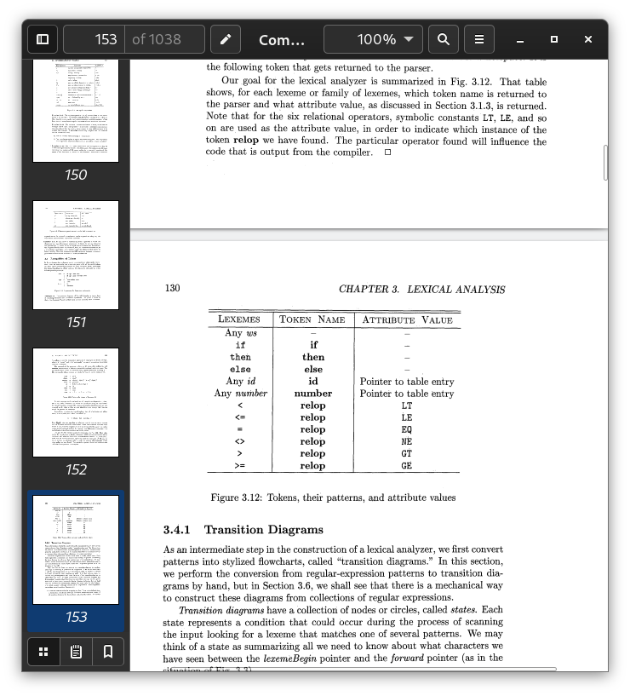

## NOTE : correction

= is not valid since it is an assignment operator

== is valid;

ID OR NUMBER : ATTRIBUTE IS THE POINTER TO TABLE ENTRY

## 

## 

## 

## TRANSITION DIAGRAMS:

1. As an intermediate step in the construction of a lexical analyzer, we first convert patterns into stylized flowcharts, called "transition diagrams.
2. Each token will be tried one after the other
3. Take one token arbitrarily and then keep checking. If none of the diagrams match(Not accepted by any DFAs, it’s a lexical error)
4. = is an assignment operator, not relop.
5. The “other” separates transition diagram from DFA
6. ‘Transition diagrams’ - generalised version of a DFA.
   1. In transition diagrams, we can use the ‘other’ arrow label as well.
7. Between = and ==; = is assignment, == is relational we assume the longest match , therefore if we have an = ; we check if the next char is a legal token ; = is not recognised by the relop transition diagram.
8. The DFA returns <getTokenName(), installID()> as a token
9. Removes comment and puts a gap

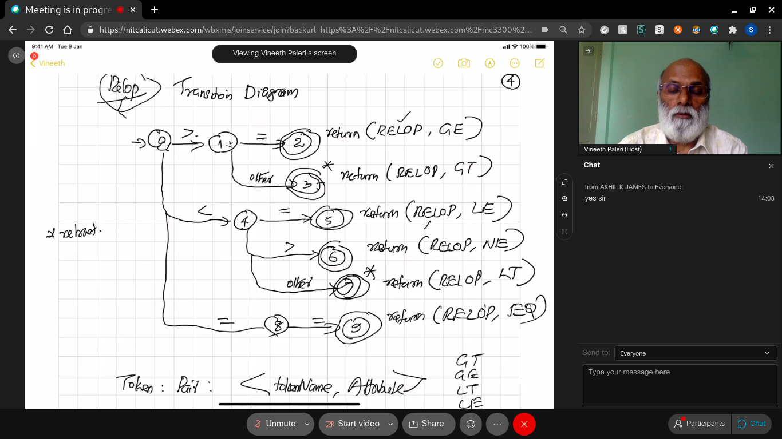

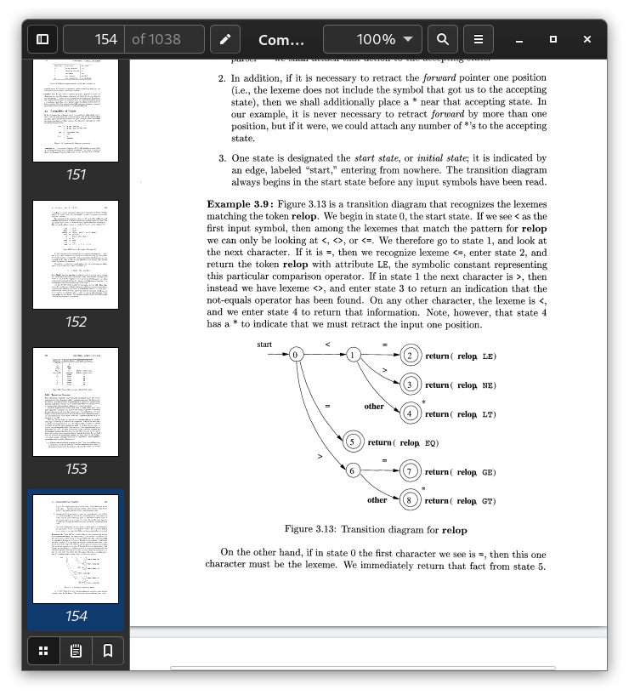

Token is represented as a pair: <token name, attribute>

Check the fig 3.8

-> This way we can always go for a longest match

**NOTE: We have to retract one character in the input string: (That’s what * means). This is just to convey that we have reached the end of the longest match. To get the next token, we retract.**

**Follow the first diagram**

We have * when there is only 1 character instead of 2 ( < , > )

* For this language, the lexical analyzer will recognize the keywords if, then,

and else, as well as lexemes that match the patterns for relop, id, and number. (This will be checked from the **reserve word table**)

* To simplify matters, we make the common assumption that keywords are also

reserved words: that is, they are not identifiers, even though their lexemes

match the pattern for identifiers.

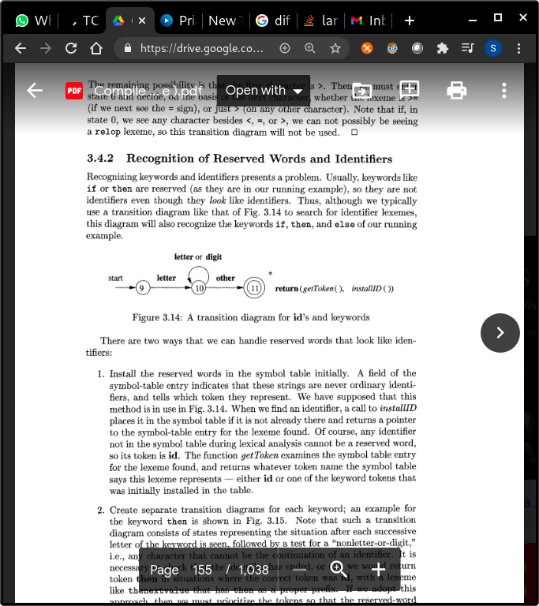

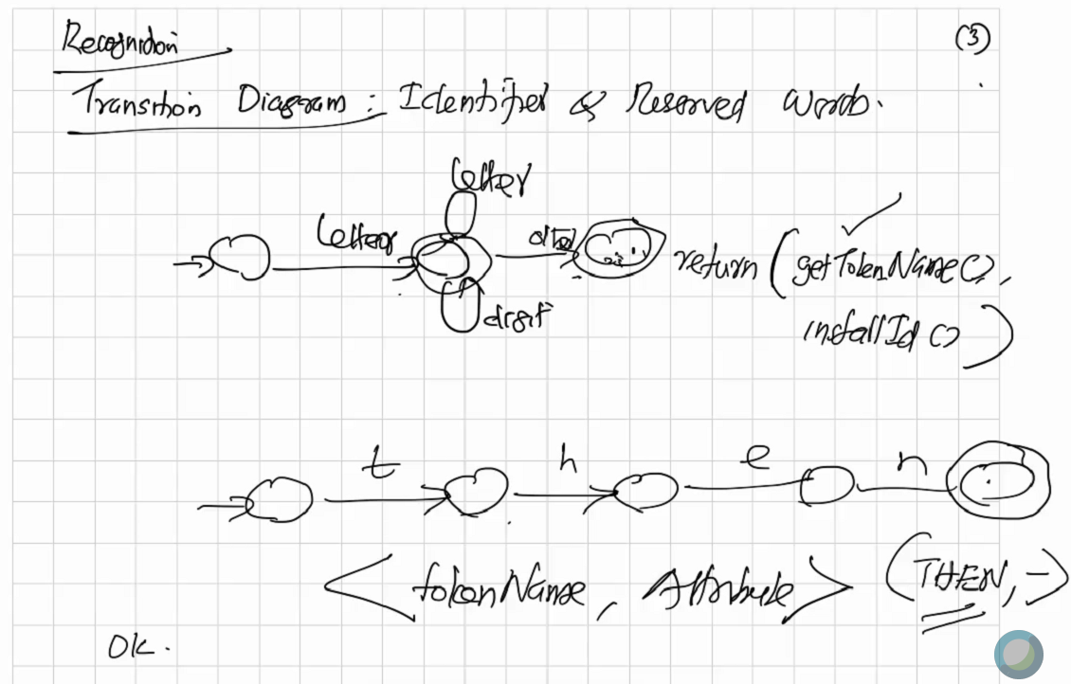

( middle state is not a final state)

When we find an identifier, a call to **installID** places it in the symbol table if it is not already there and returns a pointer to the symbol-table entry for the lexeme found.

**getToken** examines the symbol table entry for the lexeme found, and returns whatever token name the symbol table says this lexeme represents - either id or one of the keyword tokens that was initially installed in the table.

1. Install the reserved words in the symbol table initially

-> if(identifier) => installID ; specify it in the symbol table that it is an ID

then getToken

1. Sep transition diag for each keyword. (can be prioritized so that they are checked first then the other transition diags.. But we are using a diff algo. )

Get token is the name and installId is the attribute

## Implementation of Transition Diagrams

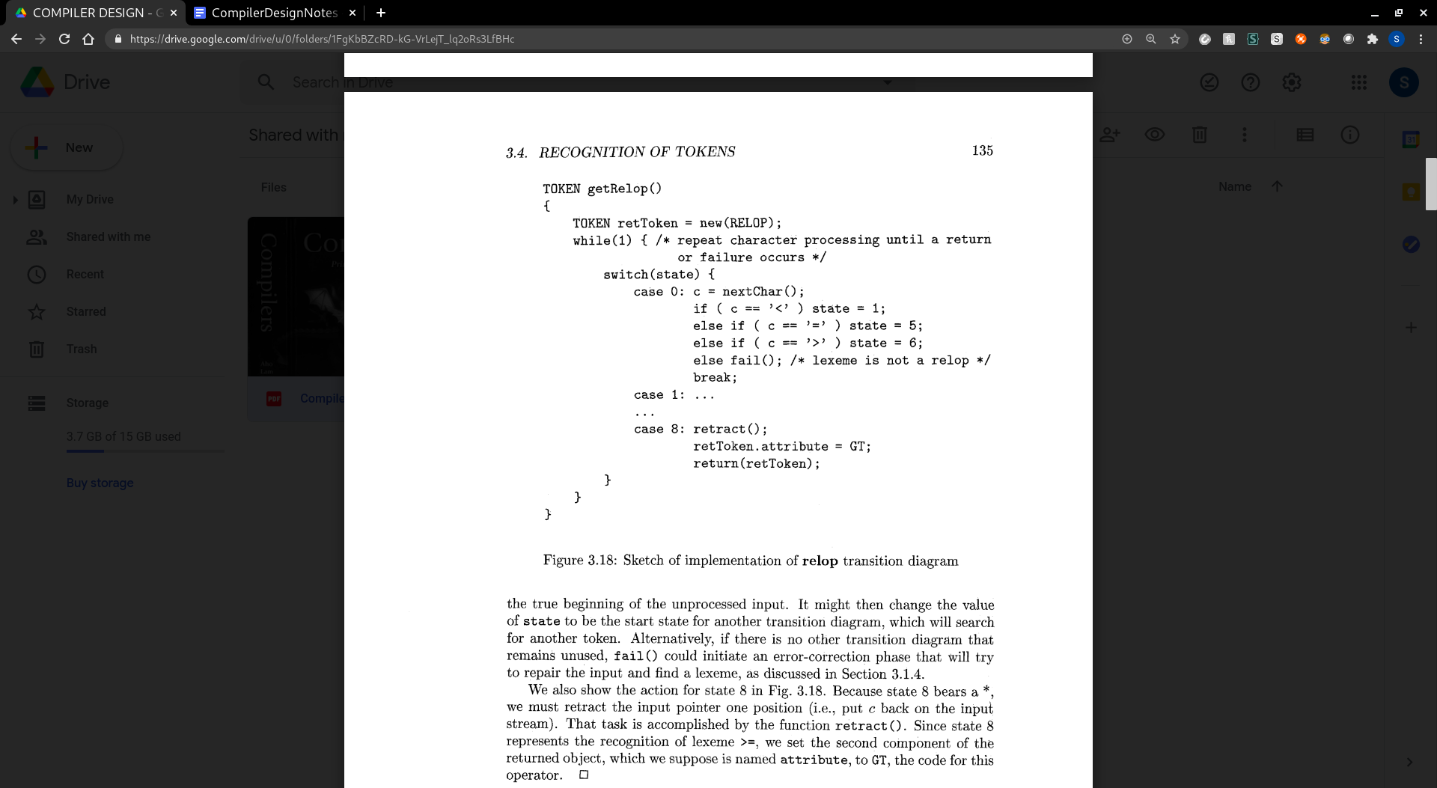

3 more cases*

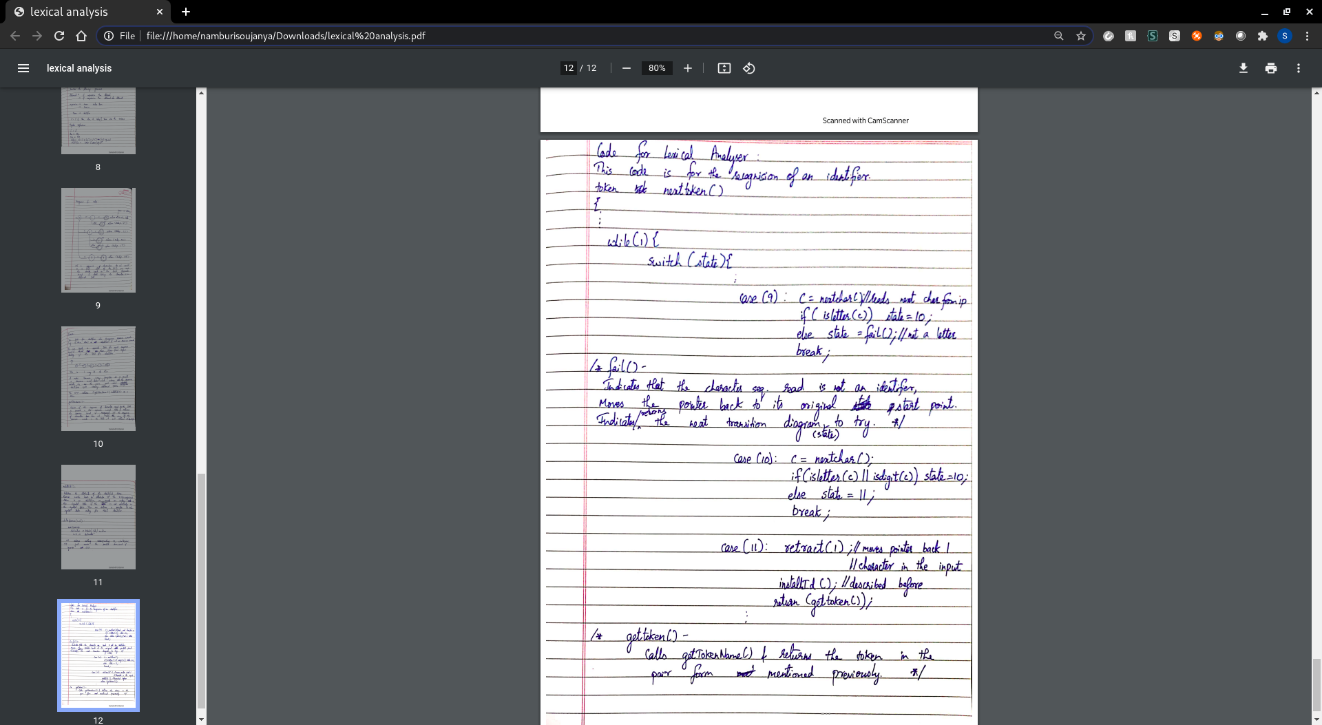

QUIZ 1:

1. Consider the following language of arithmetic expressions

E → E + T | T

T → T ∗ F | F

F → id | num

Give an input which will report a lexical error for the language.

Ans Id means letter or digit

Number means digit

And ops are +,*

Special characters are not included, therefore any character not defined there throws error. Example: a-b, $ etc

2. Give the output (tokens) of the lexical analyzer for the following input

while x === a23.4

Assume that the lexical analyzer is written for C language. In the output the tokens must

be represented using the representation we have specified in the class.

<while, null> <id, pointer_to_x_table_entry> <relop, EQ> <assignop, => <id, a23> <float num, .4>

3.Suppose C language permits single line comments as specified informally below:

The single line comment starts with the two letter sequence \*, followed by any

character sequence, and ends with the two letter sequence */ .

Write the regular definition for the single line comment.

Ans: Slash.star(character)*.star.slash

character is Letter|digit|symbols

Ans(also). /\*((.)*)\*/ (regex)

#### 

#### Lecture - 10

#### 01 - Feb

Syntax Analysis

Input: Sequence of tokens

Output: Parse Tree (or) Syntax Tree

Syntax Tree: Compressed version of parse tree with unwanted elements removed from it

* Left factoring
* Left recursion

Shouldn’t be there

Cuz

Left factoring - makes it hard to take a decision

Left recursion - don't know when to stop

-> The syntax of programming language constructs can be specified by context-free grammars or **BNF (Backus-Naur Form) notation,**

-> Every construct that can be described by a regular expression can be described by a grammar, but not vice-versa. Alternatively, every regular language is a context-free language, but not vice-versa.

Syntactic errors include misplaced semicolons or extra or missing braces. ; case statement without an enclosing switch statement,

Semantic: mismatching bw operators and operands, or return with result type void.

Types of parsers:

1. Top down - Need to make decisions about which production to use - left most derivation

* Backtracking
* Predictive parser : recursive descent and ll(1) - number of lookaheads

1. Bottom down parser(shift red parser) - decision about which part to reduce; reverse of rightmost derivation.

* Operator precedence parser ONLY PARSER THAT CAN TAKE CARE OF AMBIGUITY
* LR parser

1. SLR
2. LR
3. LALR and Clr

# 

Elimination of left recursion and left factoring in grammars:

# Context Free Grammar

G = < N, T, P, S >

N -> Set of Non-Terminals symbols

T -> Set of Terminal symbols

P -> Set of Productions

S -> Non-Terminal designated as start symbol ( initial state )

***Example:***

E -> E + E E -> E - E **N = { E }**

-> E * E E -> id **T = { + , * , / , - , id , num }**

-> E / E E -> num **S = E**

**Language defined by the grammar:**

* A set of sentences that can be derived from the start symbol
* Consists of only Terminal Symbols

*Example of sentence derivation:*

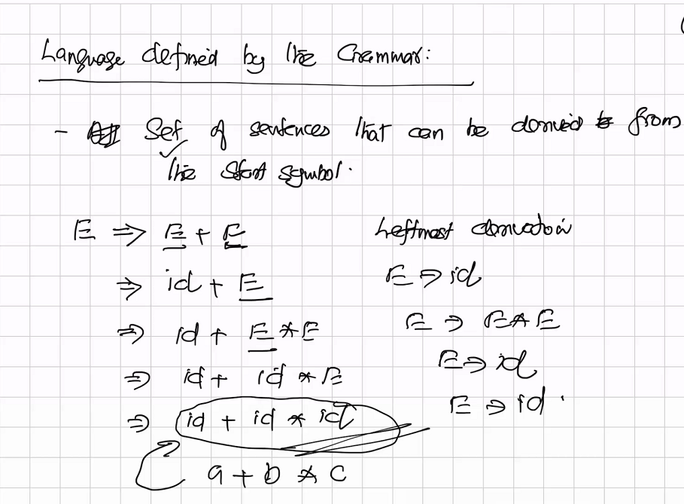

This derivation can be pictorially represented/derived using a **Parse Tree**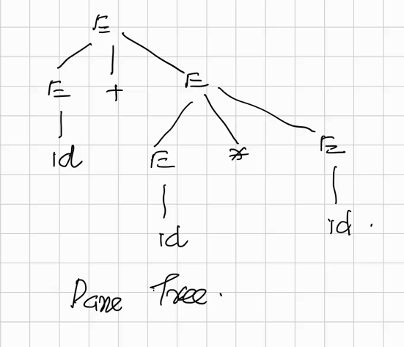

***Example of a parse tree***

a+ b*c = id + id*id

A single sentence can be derived from multiple derivations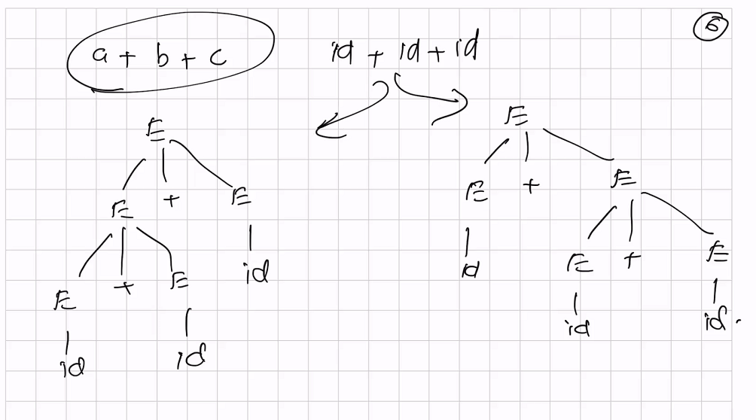

For an ambiguous grammar, we can't have a compiler.

Ex: 10 - 5 -3 : 2 parse trees can be generated

* (10-5)-3
* 10 -(5-3)

An ambiguous grammar can be disambiguated using additional rules like parentheses, precedence and associativity (outside the grammar).

## PRECEDENCE AND ASSOCIATIVITY

### Associativity of an operator:

1. **Left associative**: An operand having 2 operators on left and right will be taken by the operator on the left hand side. *Eg. a - b - c -> ( a - b ) - c*
2. **Right associative**: An operand having 2 operators on left and right will be taken by the operator on the right hand side. *Eg. a=b=c -> a=(b=c)*

### **Precedence of an operator** :

If an operand has 2 operators on left and right, it will be taken by the operator that has the higher precedence.

Eg. a + b * c -> a + ( b * c )

#### Feb 2 - lecture 11

## Top-down parsing : RECURSIVE DESCENT PARSiNG, PREDICTIVE PARSING

* Top-down parsing can be viewed as the problem of constructing a parse tree for the input string, starting from the root and creating the nodes of the parse tree in **preorder(Depth first tree)** => **leftmost derivation** of the input string
* We want the analysis to be Linear. But retracting makes it not linear

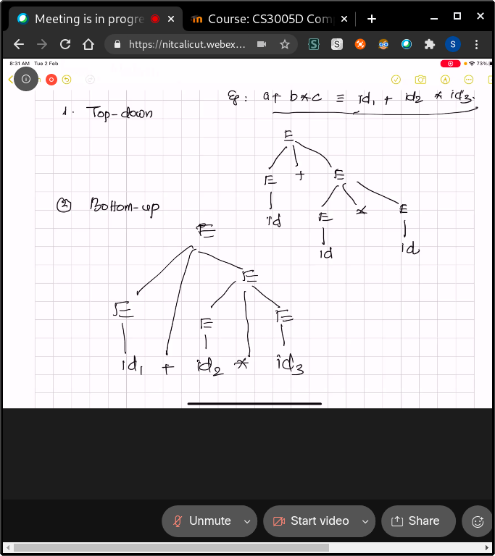

## Recursive descent parsing ; no left recursion and no nd

* Left to right scanning, might require backtracking => repeated scans over the input
* Ex: S -> cAd

A -> ab | a

input : w = cad$

The pointer is initially at c. there is only 1 production with the start symbol c and LHS is the start symbol.

* Check if the current terminal symbol is same as the symbol of the input terminal, if both have the same symbol move the input pointer further otherwise its a syntax error
* we expand A using the first alternative A -> a b to obtain the tree (2) We have a match for the second input symbol, a, so we advance the input pointer to d, the third input symbol, and compared against the next leaf, labeled b. Since b does not match d, we report failure and go back to A to see whether there is another alternative for A that has not been tried, but that might produce a match; If such a match does not exist, throw a syntax error.

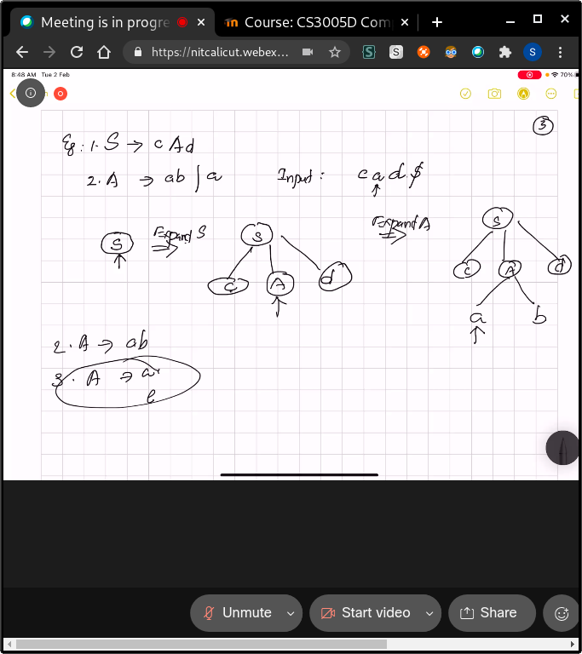

* while going back to A, retract the pointer to position 2; the position it had when we first came to A(store the input procedure in local pointer)

void A() {

1) Choose an A-production, A + XI X2 . . . Xk;

2) for (i=1 to k) {

3 if ( Xi is a nonterminal )

4) call procedure Xi () ;

5 else if ( Xi equals the current input symbol a )

6) advance the input to the next symbol;

7) else /* an error has occurred */;

Lookahead - next char from the point

**Example : e is epsilon - function for every variable. Lookahead is the pointer we’re at**

E -> iE’

E’ -> +iE | e

E() E’() match(char t)

{ if(l == ‘+’) if (l == t)

if(l == ‘i’) match(‘+’) l = getchar()

match(‘i’); E’() match(‘i’)

Else E’()

err else printf(“error")

} return;

main()

E();

if(l == ‘$’)

printf(“Parsing successful”)

i + i $

L is the main

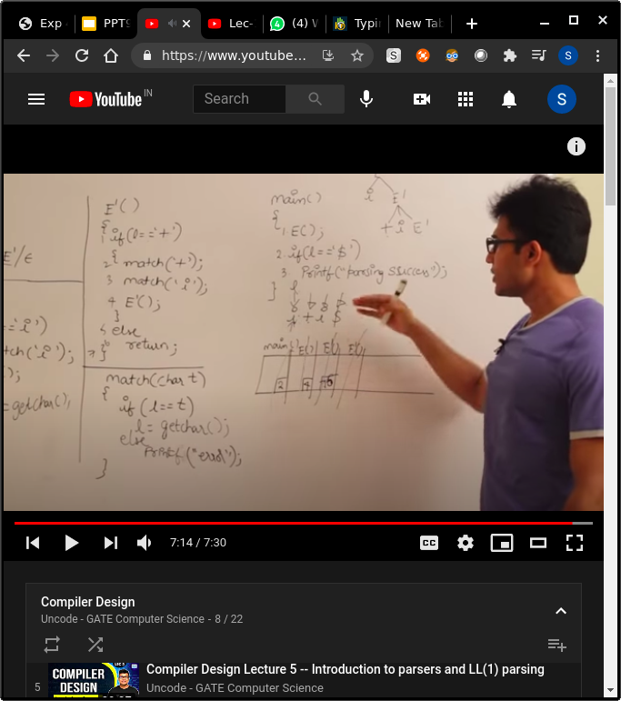

main() -> E() -> E’() -> E’() // once, we have return, we go back in the stack

#### Lecture - 12

#### 04 - Feb

## Predictive Parser (ll1 - left to right, left derivation, 1 -> lookahead at each step)

A grammar can have a predictive parser only if for any non-terminal there exists only 1 production help

So when we see one token we can figure out which production it is

The predictive parser for the previous statement

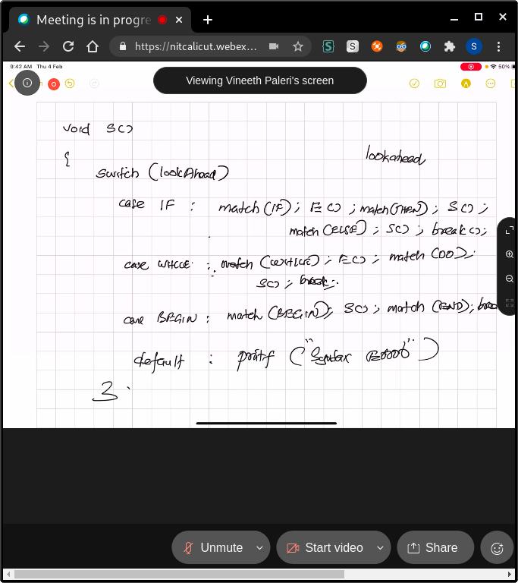

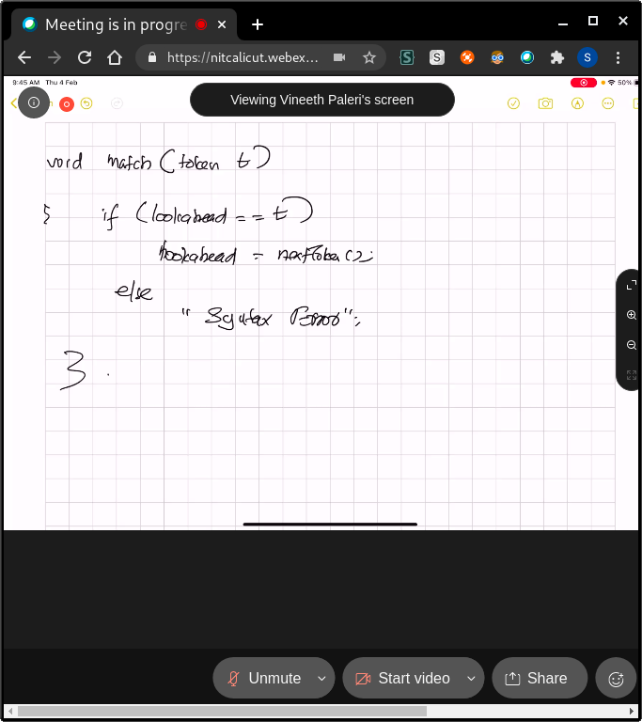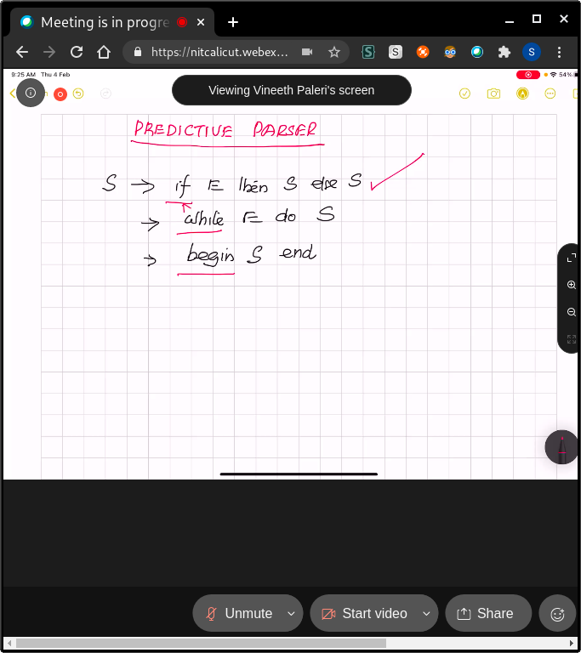

## 

## 

## 

## 

## 

-> Top down (Remove left recursion and left factored grammar)

-> Recursive Descent

(Remove back tracking)

-> Predictive Parsing

(Use table and remove recursion)

-> Non recursive predictive parser

## 

## FIRST AND FOLLOW:

Associated with the G, allow us to choose which production rule to apply, based on the next input symbol. First(alpha) ;This set is created to know what terminal symbol is derived in the first position by a non-terminal. where alpha is a string of symbols, to be the set of terminals that begin strings derived from alpha.

Ex: α → t β

That is, α derives t (terminal) in the very first position. So, t ∈ FIRST(α).

* if α is a terminal, then FIRST(α) = { α }.
* if α is a non-terminal and α → ℇ is a production, then FIRST(α) = { ℇ }.
* if α is a non-terminal and α → 𝜸1 𝜸2 𝜸3 … 𝜸n and any FIRST(𝜸) contains t then t is in FIRST(α).
* (check if those gammas contain epsilon) first of alpha is the first of gamma1; check stuff about epsilon too.

S -> ABC ; A -> a|b| ℇ ; B -> c|d| ℇ ; C -> e|f| ℇ ;; then first - a,b, c,d, e,f,epsilon

## FOLLOW set: canot have epsilon cuz $ is always there

(focus on the right) we see what would be the next terminal symbol that follows the productions of a non-terminal; set of terminals that appear to the right in some sentential form. (some stage starting there) follow never contains Epsilon

S-> alpha A a beta

S -> AB // B follows A

Algorithm for calculating Follow set:

* if α is a start symbol, then FOLLOW(S) = $

If A can be the right most symbol, then $ belongs to Follow(A)

* if α is a non-terminal and has a production α → AB, then FIRST(B) is in FOLLOW(A) except ℇ.
* Repeat this until no change.
* S -> ACD follow(D) = follow(S)
* *\*\*If A->pB or A-> pBbeta and (first (beta) contains epsilon)is a production, then everything in FOLLOW(A) is in FOLLOW(B) cuz B is the end of A, So we add everything after A to B coz they are one and the same thing*
* *if α is a non-terminal and has a production α → AB, where B contains ℇ, then FOLLOW(A) is in FOLLOW(α).*
* *If A->pBq is a production and FIRST(q) contains Є, then FOLLOW(B) contains { FIRST(q) – Є } U FOLLOW(A)*

Follow set can be seen as: FOLLOW(α) = { t | S *αt*}

#### Lecture 14 Predictive Parsing: Construction of Parsing Table

For each production A-> alpha of the grammar, do

1. For each terminal a in first(alpha), add A -> alpha to to M[A, a]
2. If epsilon is in first(alpha), add A-> alpha into M[A, b] for each b in Follow(A)
3. Make each undefined entry in M be error.

Follow(E) = {$ }

Follow (E’) = Follow(E)

Follow (T) = Frst(E’) = {+, epsi} ; so substitute with epsi and check again. Therefore; Follow(E’)

Follow(T’) = Follow(T)

Follow(F) = First(T’) = {epsi, *,} ; = follow(T’)

|  |  |  |
| --- | --- | --- |
| Example | First() | Follow() |
| E -> TE’ | {id, (} | {$, )} |
| E’ -> +TE’|E | {+, epsi} | {$. )} |
| T -> FT’ | {id, ( } | {+, $,), } |
| T’ -> *FT’|epsi | {epsi, *,} | {+, $,)} |
| F -> ( E )| id | {id, ( } | {*, +, $, )} |

### Construction of a parse table: wont be accepted if there are 2 entries in 1 box

1. Rows: non terminals
2. Columns: Terminals is the first of right side of the production

|  |  |  |  |  |  |  |
| --- | --- | --- | --- | --- | --- | --- |
|  | id | + | * | ( | ) | $ |
| E | E -> TE’ |  |  | E -> TE’ |  |  |
| E’ |  | E’ -> TE’ |  |  | E’->epsilon | E’->epsilon |
| T | T-> FT’ |  | T->FT’ |  |  |  |
| T’ |  | T’->Epsilon | T’->*FT’ |  | T’->epsilon | T’->epsilon |
| F | F->id |  |  | F->(E) |  |  |

* First of right hand side productions of each production
* E -> TE’ should be kept in first of right hand production = first of(TE’) = First of (T)
* E -> TE’| Epsilon. First of (epsilon) is Follow of E

Method 2:check for every production

* S -> a1 | a2 | a3 no null epsilon:

First(a1) intersection first(a2) intersection first(a3) = phi ? then LL1; else not

* If there is an epsilon: Follow (S) intersecion First(a1) intersection first(a2) intersection first(a3) = phi ?

***A grammar G is LL(1) if and only if whenever A -> 𝞪| 𝜷 are two distinct***

productions of G, the following conditions hold:

1. For no terminal a do both 𝞪 and 𝜷 derive strings beginning with a.
2. At most one of 𝞪 and 𝜷 can derive the empty string.
3. If , 𝞪 => 𝜷 then cu does not derive any string beginning with a terminal

in FOLLOW(A). Likewise, if & t, then P does not derive any string beginning with a terminal in FOLLOW(A).

#### LECTURE 13 LL1 -> left to right scanning + Left most derivation FEB 5; TOP DOWN PARSING; 4.3 idk wtf is happening anymore;

LL 1 : 1. Left to right; left most derivation; 1 lookahead.

Push down automata = DFA + stack // to get rid of recursion.

Dollar at the bottom to indicate it is done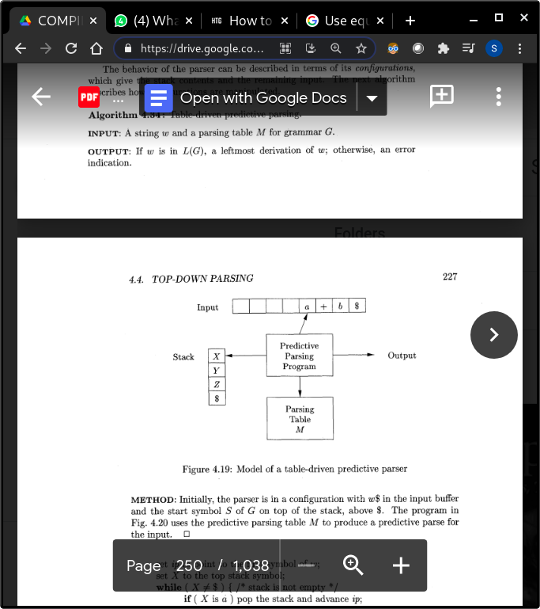

Stack: contains the symbols; initially, S and $; then replace S with the right expression.

* If the top is a terminal symbol, call the match( ) function.

Pop off the symbol == moving the pointer on the parse tree.

* If the top is a non terminal; It will look at the production, fill the stack

( Parsing table; 2d array ; [A, a] : term, nt)

* A -> XYZ

Then x, y , z should be pushed into the stack after popping a from the stack. X should be on the top. If there is no production => syntax error.

* Successful completion when the input pointer points to $ and stack also points to the $
* Output : the production whenever we consult the table.

**Example:**

S -> cAd

A -> a

**Parsing table: NT vs T:**

**Take a (value at ip pointer, value at stack) production - change the variable in stack; pop and push**

c a d $

|  |  |  |  |  |
| --- | --- | --- | --- | --- |
| S | S -> cAd |  |  |  |
| A |  | A -> a |  |  |

***Highlighted stuff- consult the table - last in first out***

|  |  |  |
| --- | --- | --- |
| **Stack** | **Input** | **Output** |
| $ S | cad$ |  |
| $ d A c | cad$ //ip = stack ; so pop | S -> cAd |
| $ d A | ad$ |  |
| $ d a | ad$ | A -> a |
| $ d | d$ |  |
| $ | $ | accepted |
|  |  |  |

**Use the output to construct the parse tree**



**Go from bottom to top**

#### LECTURE 15 FEB 9; Bottom-up parser; tiger book

* Build the parse tree from leaves to root. Bottom-up parsing can be defined as an attempt to reduce the input string w to the start symbol of grammar by tracing out the rightmost derivations of w in reverse.
* *Instead of reducing directly, reduce only if the next input symbol is in FOLLOW of the Non-Terminal of the production we are planning to reduce else Shift.*
* This parser is also called **LR(0)** parser (check for the first match then reduce) - No lookahead. - Blindly reducing.
* The parser where we check for other matches before reducing is called **SLR - check the follow before reducing.**
* As we push the input into the stack, each push we check if it matches with any of the RHS of the productions, if does, reduce it to the LHS.
* A shift-reduce conflict appears when we reduce instead of shift which results in failure of parsing.

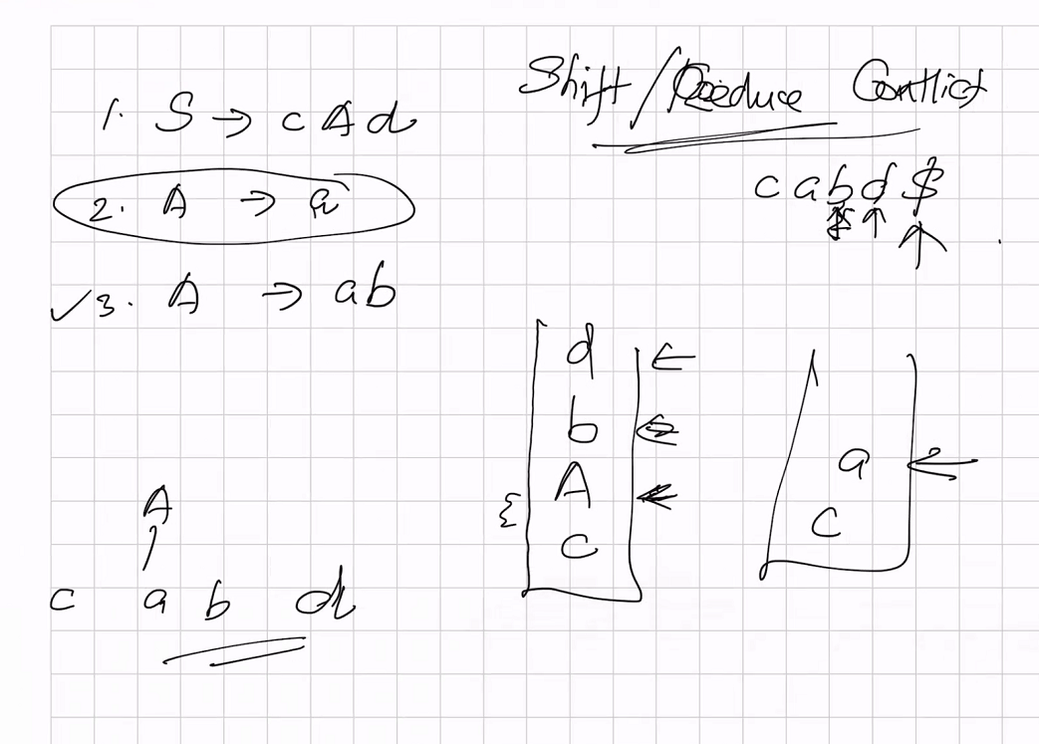

* Ex: from the tbk

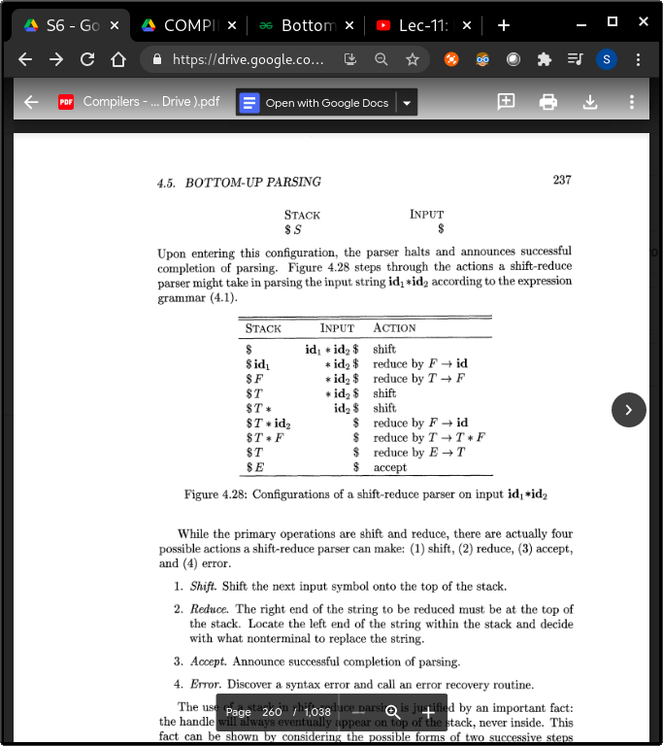

**EX1**

**Input = cad$**

**Production rule: S-> cAd; A -> a; (LR0)**

STEPS:

1. Push the first symbol (the leftmost one) into the stack and shift the pointer.
2. C isn't in any production, so shift, therefore ca… a is in a production so pop a put A.
3. Shift d, d A c … sequence corresponds to the rhs of the thing. Pop 3 and shift NT into the stack, S $... therefore successful

Shift reduce is only for the action. Not goto.

**Ex2 : S-> cAd; A-> a; A-> ab; input is cabd (SLR1)**

1. Shift c, shift a, ; if we reduce a with A, we get c A then c A b. Which is recognised as wrong even if it is correct. This is called shift- reduce conflict. (if a should be reduced or not)
2. The NT a should be reduced to A only if follow(A) *{follow (non terminal to which it has to be reduced to )}*has the next input symbol b
3. If b is in follow(A), then we reduce a, else shift before reducing.

#### Feb 11 Lecture 16

## lr(0) parsing; shift and reduce cant be in the same box - shift reduce

While the primary operations are shift and reduce, there are actually four

possible actions a shift-reduce parser can make: (1) shift, (2) reduce, (3) accept,

and (4) error.

**1. Shift.** Shift the next input symbol onto the top of the stack.

**2. Reduce**. The right end of the string to be reduced must be at the top of

the stack. Locate the left end of the string within the stack and decide

with what nonterminal to replace the string.

**3. Accept.** Announce successful completion of parsing.

**4. Error.** Discover a syntax error and call an error recovery routine.

1. S -> cAd
2. A-> a

w = cad$

|  |  |  |
| --- | --- | --- |
| **Stack** | **Input** | **Action** |
| $ | cad$ | shift |
| $ca | ad$ | shift |
| $cA | d$ | Reduce A-> a |
| $cAd | $ | shift |
| $S | $ | Reduce S-> cAd |

Look at the stack and get the matching production

-> productions in action column should be from bottom to top to construct the parse tree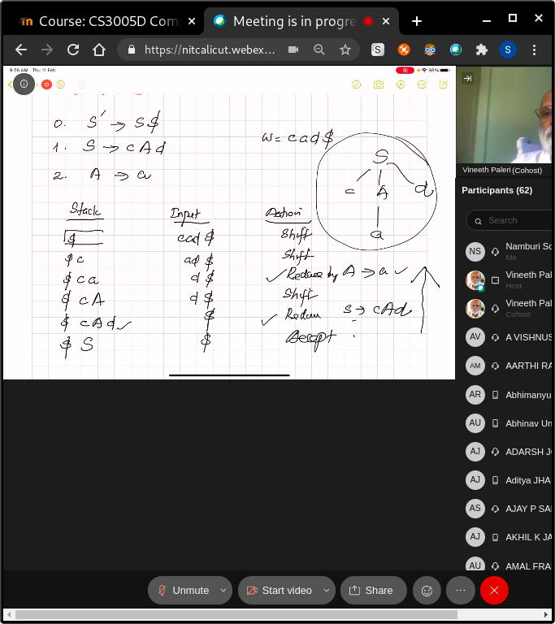

Content of states is items.

We need to augment E’ -> .E

S.$

S’ -> .S$ //where the dot indicates the current position of the parser.

In this state, where the input begins with S, that means that it begins with any possible right-hand side of an S-production; we indicate that by

S’ -> .S$

S-> .cAd ---->(on shift c)

. is in front of a NT. use the production of that nt too.

State is the item. DFA formalises the stack.

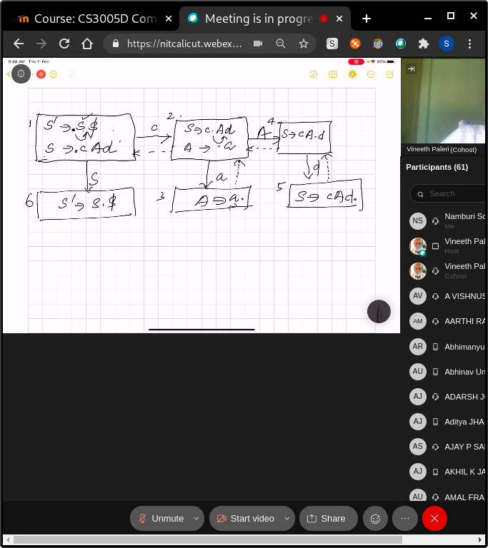

* If . in front of a NT, write all productions of that NT. if its a terminal, do nothing.
* . is in the end => that is reduction => pop it.

. tells you where you are rn.

Open the Non terminal after the .

Accept when . is in the end * that . will be reduced ; s4/ reduced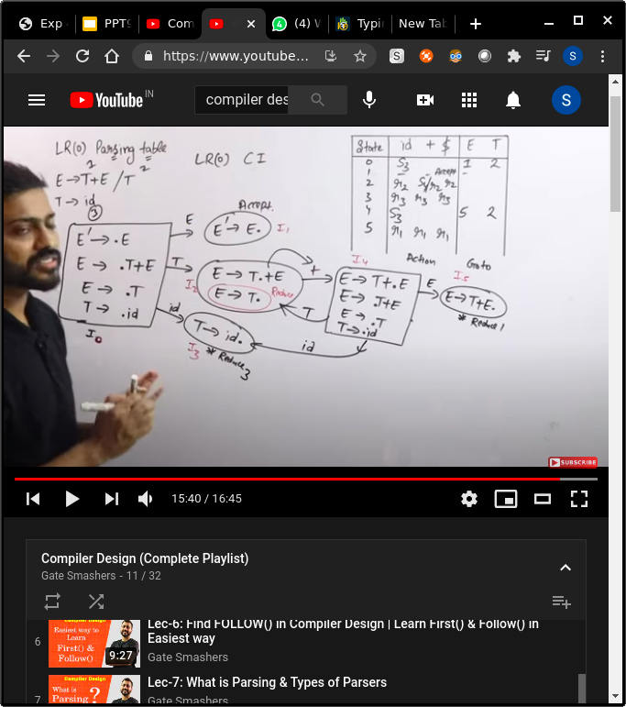

S - shift

Write the reduced production in the state which has the final state

That box thing is called a canonical item - goto - shift the dot

**. after start symbol: ACCEPT  
. after T : reduce**

**Action: for terminals ; shift 3 or something**

**GOTO : for variables when there is a reduce term, put it in every box of the action**

# 

#### Lecture 17 SLR parsing

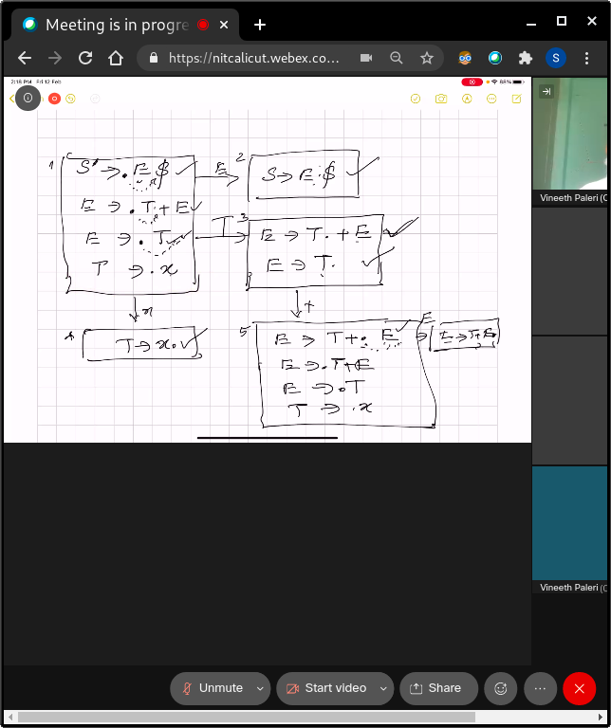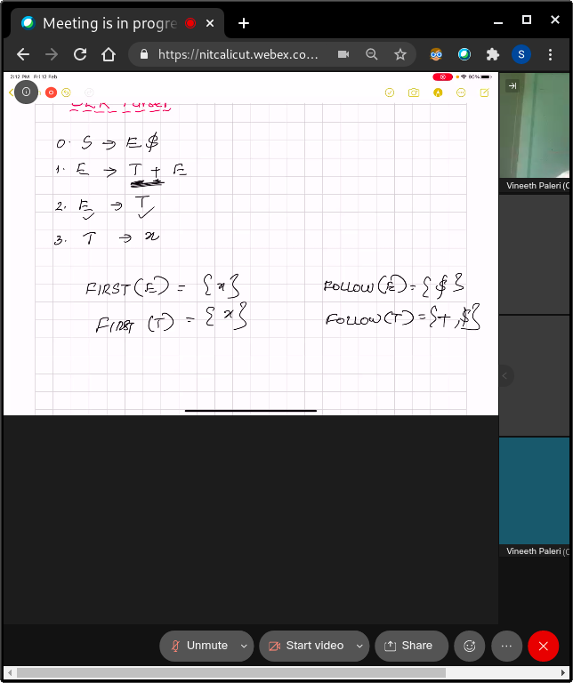

* We can't have LR(0) parser if we have a shift reduce conflict.
* We do the reduction if the next input symbol is in the follow of the nt
* Stack state is identified using the DFA; don't have to scan the whole stack, it is remembered by DFA’S state.
* If there is no conflict, just parse it.
* Grammar
* Find follow and first
* Construct dfa
* Make the table
* Check if there is a conflict.

Done

* **We wrote reductions in the whole row… we can't do that. Ex: E -> T.**

**Reduction should be in Follow(E) follow of the left hand side of the reducing production**

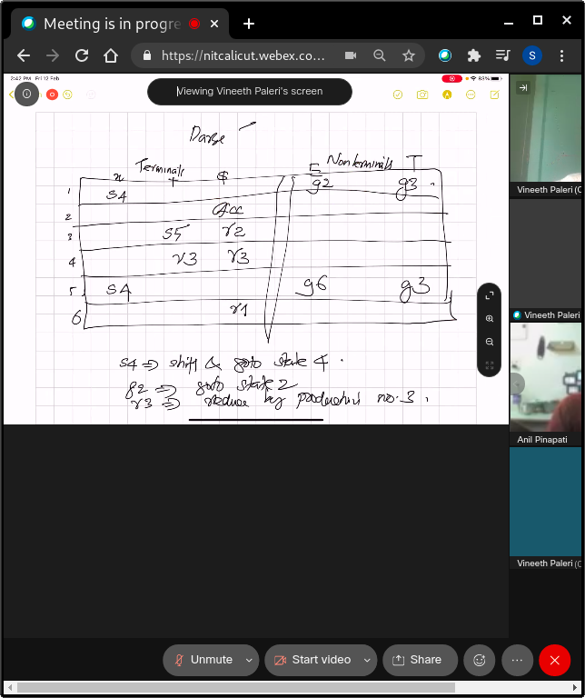

SLR (1) refers to simple LR Parsing. It is the same as LR(0) parsing. The only difference is in the parsing table.To construct the SLR (1) parsing table, we use canonical collection of LR (0) items.

In the SLR (1) parsing, we place the reduced move only in the follow of the left hand side.

Various steps involved in the SLR (1) Parsing:

* For the given input string write a context free grammar
* Check the ambiguity of the grammar
* Add Augment production in the given grammar
* Create Canonical collection of LR (0) items
* Draw a data flow diagram (DFA)
* Construct a SLR (1) parsing table

Empty = error

#### CLR Parsing table LR 1 canonical items

1 lookahead

Example: S -> aAd | bBd | aBe | bAe

A -> c

B -> c

1. Augment - S’ -> .S, $ --- lookahead is $ Lookahead of what we open = **first of wtv is remaining**

Conflicts are only in action . not goto



**Write the reduced things in the lookahead places,**

##### LALR PARSER

* LALR is weaker than CLR
* CLR has the most number of states
* Do the same thing what u did with CLR
* Then we should merge
* We should merge the states where there are different lookaheads to 1 state
* Ex: Merge 5 and 6 -> create a new state R 56 - write r 56 instead of r 5 r 6
* **Can't be LALR when there are more than 1 reduced states in a same box - that will be clr not lalr; example: wtv is represented in the diag above. A -> c, e; A -> c, d….**

EX: A->.c, e; B->.c, d …………… A ->.c, d; B-> c., e when merged ..

1, e has r5 and r6

1,d has r5 and r6 too

1. Closure(I)
2. Goto (X)
3. Algo for dfa construction using closure and goto .

..do from the red tiger tbk😱😱

Another one...LR1 ugh.

##### Lecture 18

##### Feb 15, 2021

Types of LR parsers”

1. LR(0) -
2. SLR 1 -
3. LALR 1 - Lookahead LR
4. CLR - canonical LR

Yellow: LR0, Pink: lr1 canonical items

Augment another production

Item: any production with the .

Reduce only if the . is in the end

**CLOSURE:**

* Initially every item in I is added to closure(I).
* If A -> α.Bβ is in closure(I) and B -> γ is a production then add the item B -> .γ to I, If it is not already there. We apply this rule until no more items can be added to closure(I).

**Ex: closure(S’->S): S’->.S ------------------Non terminal so, add production of S**

**S-> .AA -----------------------------Non terminal so add production of A**

**A->.aA/.b**

**GOTO operation:**

Goto(I, X) = 1. Add I by moving dot after X.

2. Apply closure to the first step.

Ex: Goto(S’->.S, S) = S’ -> S. // nothing after dot, so no closure

The whole thing is the canonical collection of stuff

S’->S

S->AA

A->aA/b

S->A.A; A->.aA/.b ---on a---> A->/a.A; A->.aA/b

Action: terminals; goto: nonterminals

SHIFT: Whenever the state is going to another production with a terminal

GOTO: Same but with a variable

Augmented production should be accept

Whenever you see a production with a dot,

***Example:***

aabb$ -> increment the input pointer everytime we shift

r3 is A->b; length of the left hand thing is 1 therefore reduce the two times the left stuff and add the right hand side stuff to the stack - 0a3a3A need a state on top; therefore 3 on A will go to 6

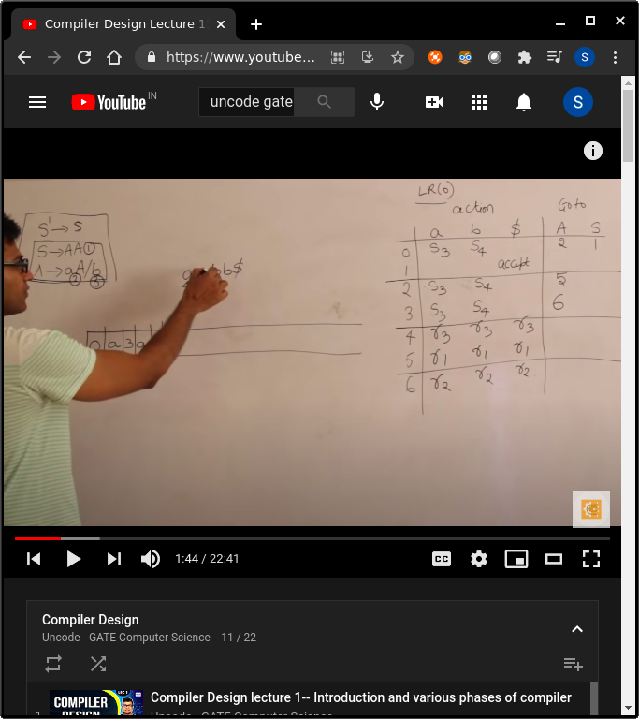

LR (1) item is a collection of LR (0) items and a look ahead symbol.

LR (1) item = LR (0) item + look ahead

The look ahead is used to determine that where we place the final item.

The look ahead always add $ symbol for the argument production.

S->AA  
A -> aA/b

Step 1: augmented step+ lookahead

S’->.S,$ //lookahead is always $ for augmented stuff

S -> .AA, $ // lookahead is the first of the production left after the .NT here, after .S we have $. So add the first($)

A->.aA , a/b first(A,$) = a. b

/.b, a/b

Different lookaheads = diff items ; therefore there are more items

Lookahead does not change with transition

MIght change with the closure  
Find the lookahead in every step

More spaces = More error detecting capability

Merging: to get LALR1 = number of states of slr and lr 0 and lalr 1 are same = UNION

If states have same productions with different lookaheads

If we are merging 3 and 6, replace all shifts with 3/6 to 36 , not r

We place the final items in the lookahead symbols box of the table

Not the whole row nor follow of sth like slr

**SR AND RR CONFLICT**

A -> alpha,a

LR1 AND LALR1

<https://www.youtube.com/watch?v=sMxqUQc_jHQ&ab_channel=GateSmashers>

Instead of reducing directly, reduce only if the next input symbol is in FOLLOW of the Non-Terminal of the production we are planning to reduce else Shift. - follow wrt that production. Not the whole grammar

More powerful by reducing the following set.

A->aBc

A ->dBe

B->b

Follow of B is c and e; but we should see only c . not c and e for the production A->aBc

LALR1

<https://www.youtube.com/watch?v=VSkfnRfNuwI&list=PLEbnTDJUr_IcPtUXFy2b1sGRPsLFMghhS&index=14&ab_channel=Uncode-GATEComputerScience>

LALR refers to the lookahead LR. To construct the LALR (1) parsing table, we use the canonical collection of LR (1) items.

In the LALR (1) parsing, the LR (1) items which have same productions but different look ahead are combined to form a single set of items

LALR (1) parsing is the same as the CLR (1) parsing, only difference in the parsing table.

S

## Test : 1 discussion - why am i here

Can parse higher set of grammars: -> more powerful

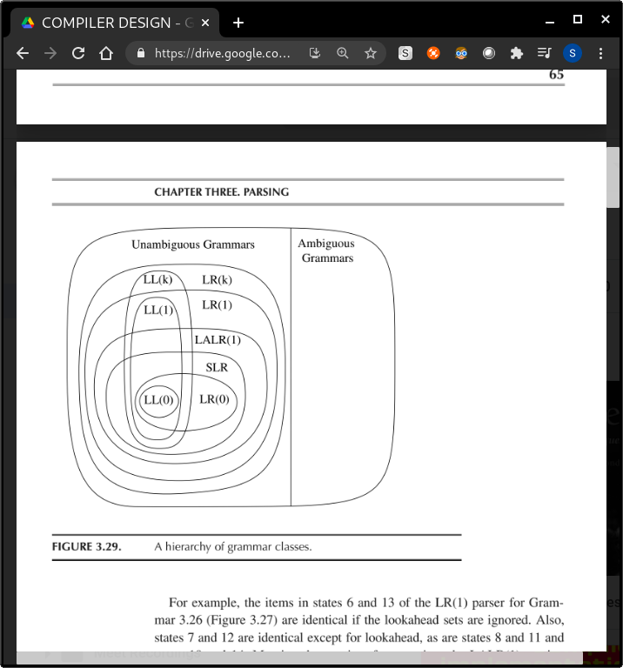

1b. If the stack contains $ and not s after that

Then it is that conflict

#### Lecture 20 February 23, 2021

## Syntax directed Translation

Syntax directed translation: we can call a compiler as a translator. We see the syntax and using the grammar, we translate to the intermediate code. The translation would be completely driven by the syntax. When we traverse the tree bottom,up, we have attributes(associated with grammar symbols) and semantic actions(reduction)(associated with productions).

### Intermediate code Generation:

**Input** = Parse Tree, **output** = intermediate code(3 address code)

Traverse bottom up, use temporary variables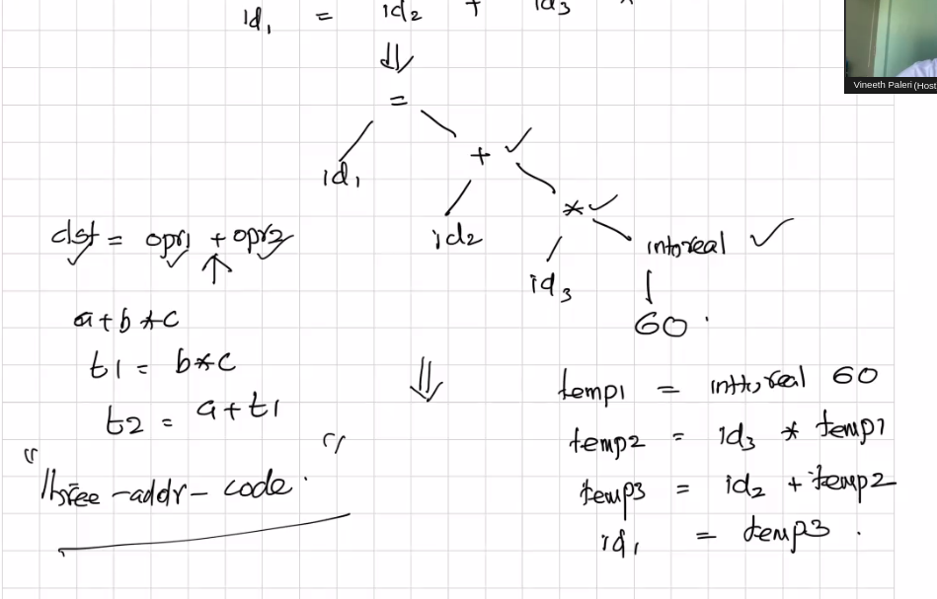

2 methods - top down and bottom up

SDT :

1. Attributes for grammar syntax
2. Action: semantic action

Therefore SDT = grammar + semantic analysis ; f.val = digit.val We get the dig.val from the lexical analyser.

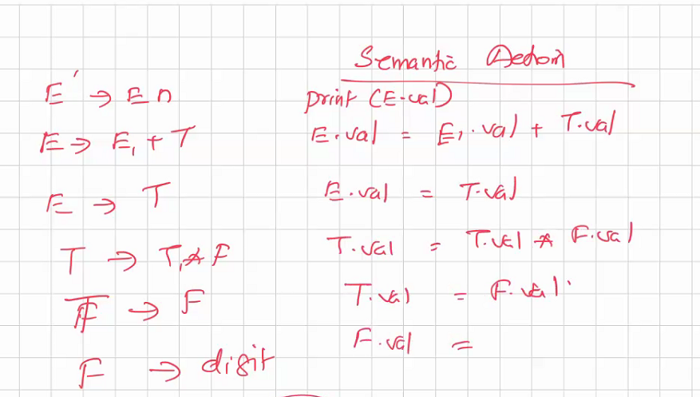When you shift, you take the value

When you reduce, we do the calculation and store in temp variable

*For each production rule, we write a semantic action corresponding to that rule*

We get the val thats with the token value pair of that token

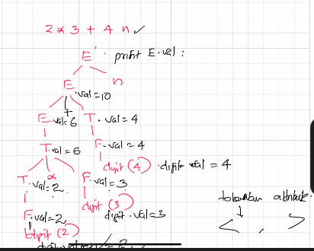

## 

#### Lecture 21

#### February 25 2021

## Syntax Directed Definitions

* **Grammar + Semantic action**

Regular expressions cannot check balancing tokens, such as parenthesis. Therefore, this phase uses context-free grammar (CFG), which is recognized by push-down automata.

**Translation Scheme**

* For each Terminal and Non Terminal, you can perform certain semantic actions on encountering the symbols (not always necessarily at the end)

**Key:**

* Attributes of the grammar
* Semantic actions

Ex: convert an infix expression to postfix

Parser takes care of the actions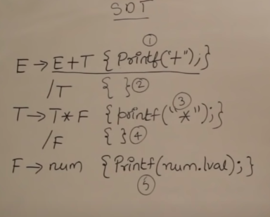

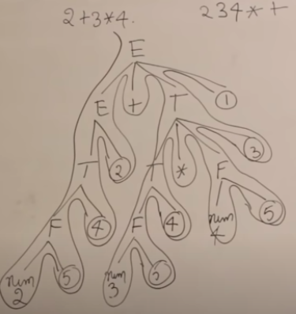

**Top down parser:**

Parses the tree from top to bottom left to right - if it comes across any semantic action - it does it

Number the actions - better ;

**Bottom up parsers mainly depend on the directions**

* Bottom to up - if reduced, do the action - same tree= semantic action is different - check the reduction properly

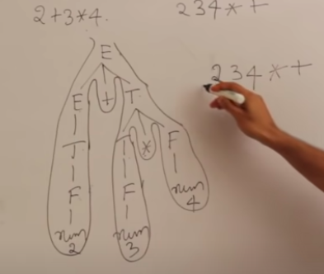

**Draw an outline stuff - better**

**Defined first = lower precedence**

**Check the associativity too**

## Sdt applications:

1. Executing arithmetic expressions
2. Infix to postfix/prefix conversions
3. Binary to decimal
4. Counting the number of reductions
5. Creating syntax tree
6. Generating intermediate code
7. Type checking
8. Storing type info into symbol table

Rules + actions

Make a parse tree first then use the rules

Ex: 5#3&4

= 5*3+4

1. Top down vs bottom up

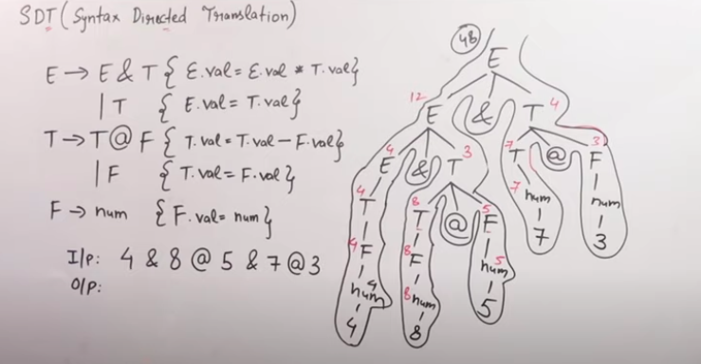

## *S attributed vs l attributed sdt*

### S attributed :

* Based on synthesized attribute
* Uses bottom up parsing
* Semantic rules are always at the rightmost position in RHS

### L attributed :

* Based on both synthesised and inherited attributes child can take from - parent , left sibling
* Top down
* Semantic rules can be anywhere in RHS

## Types of Attributes

1. Synthesized : Calculated from values of its children ; left takes from right

Ex : A -> XYZW : A gets it from XYZW

1. Inherited : Attributes which require information from its parents or its siblings : right to left

A is giving its attributes to X/Y/W/Z

Or W takes from its siblings. Like X Y or Z

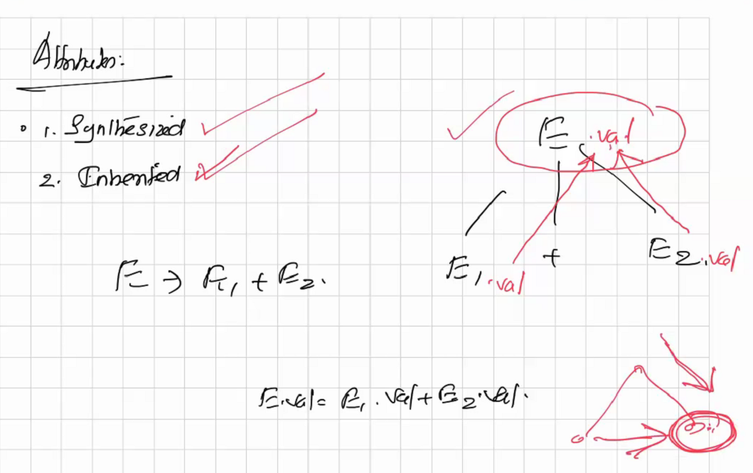

## 

## Inherited Attributes

Eg. int x, y, z;

Grammar for declaration -

D -> T idList

T -> int | float

idList -> idList, id | id

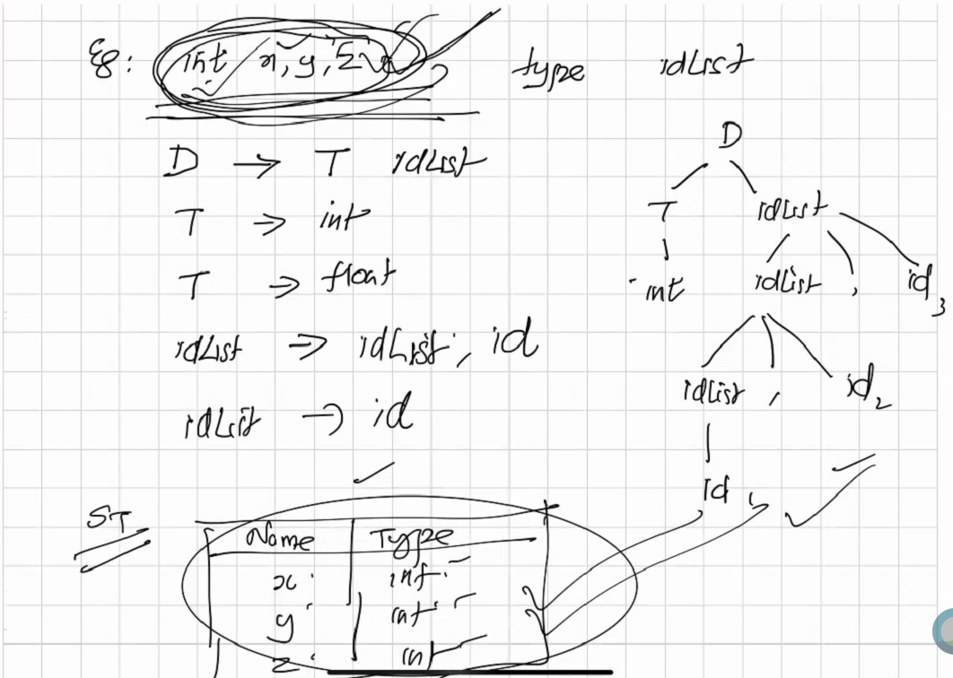

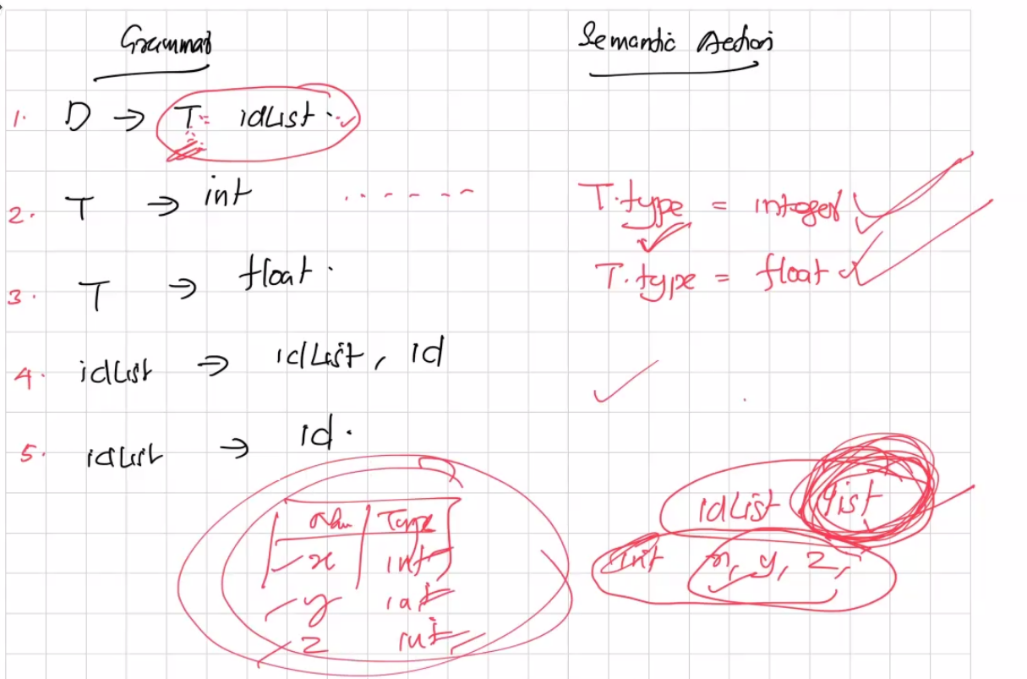

#### Lecture 23: Syntax Directed Translation: Inherited Attributes

#### March 1 2021

For the above example,

Production 4 and 5, we use a list as an attribute to idList. When an id is encountered in them, push id into the idlist (synthesised attribute)

Finally, from production 1, we add each element of idList to the symbol table with the type found under T

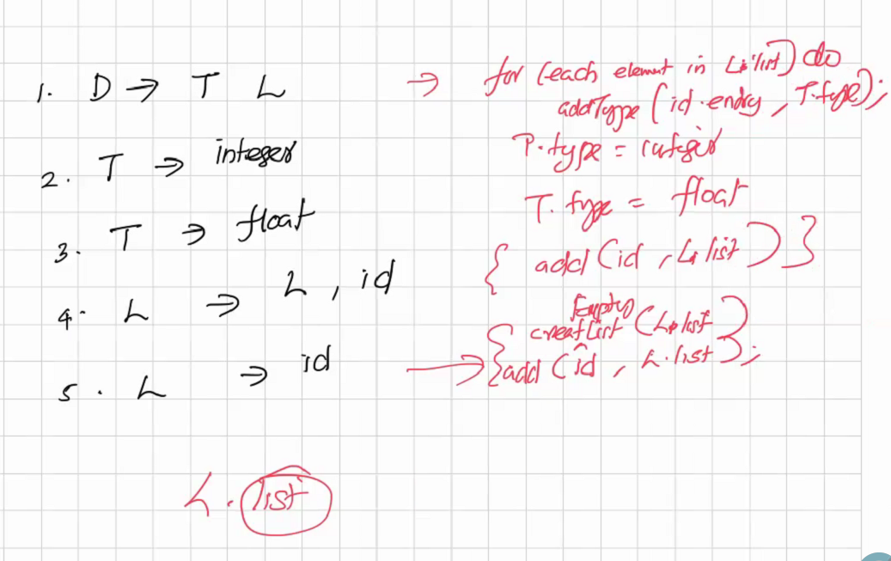

**Using inherited attribute,**From a sibling, the idList inherits an attribute, **idList.in = T.type**

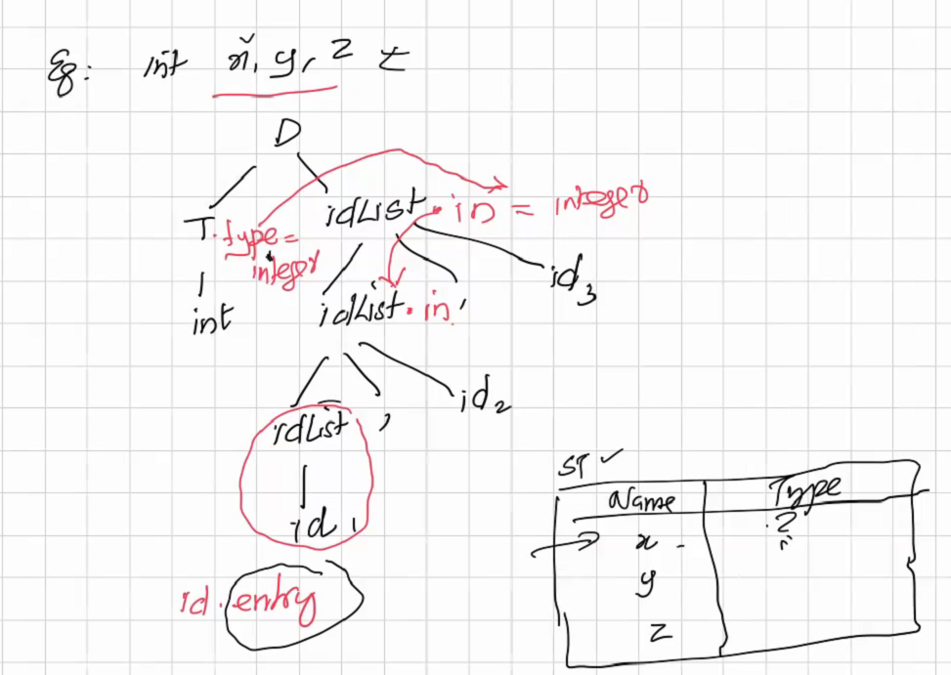

For each child of idList being idList, it inherits the parent idList’s type

=> all 3 idLists will inherit the type of T

Upon reaching id, the action is **addType(id.entry, idList.in)**

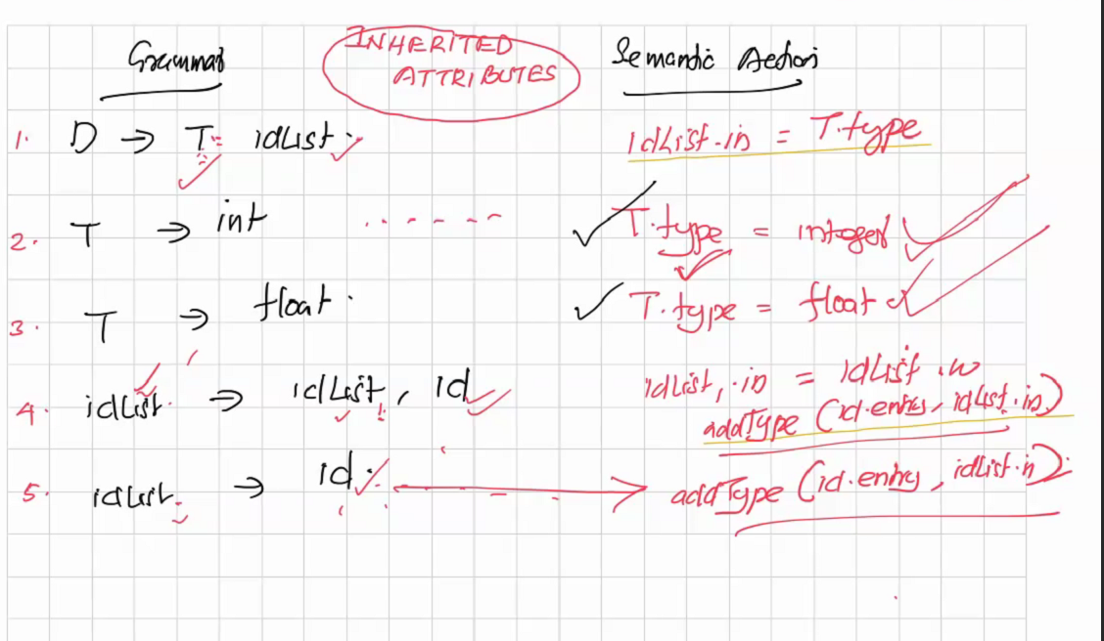

Question: How many parses over the parse tree do we make to solve any problem?

#### Lecture 24: Ordering of Evaluation of Attributes March 2 2021

**Order of Evaluation of Attributes**

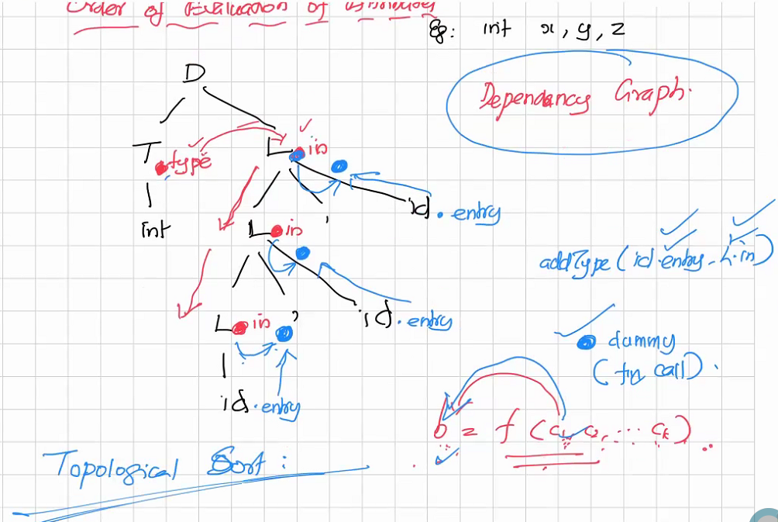When attributes depend on something, we will be required to compute them before computing the actual attributes. For this purpose we use a dependency graph to depict the dependencies of the attributes, followed by a topological sort to resolve this.

Eg. L.in depends on T.type to be calculated before it can be calculated.

**Closing of syntax directed translation**

**???**

## Semantic Analysis

Examples :

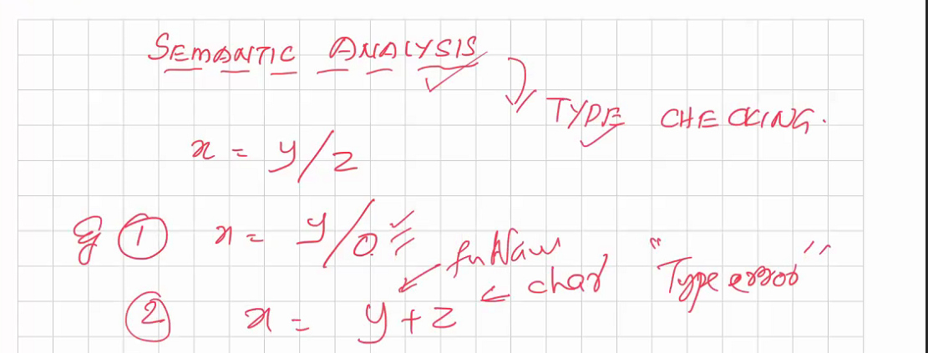

Type:

Set of values

Set of operations

Proper definition is necessary for any type. It should be independent of the machine architecture.

Types are of 2 types - basic and constructed

#### Lecture 28: Type Checking 9 March 2020

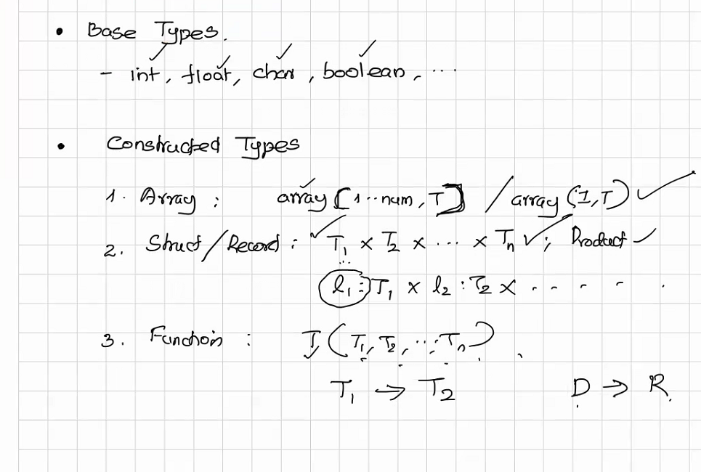

Examples for base and constructed types

### Type Checking

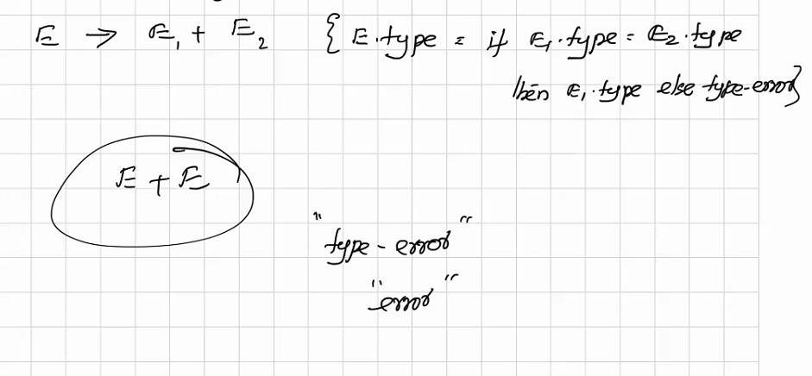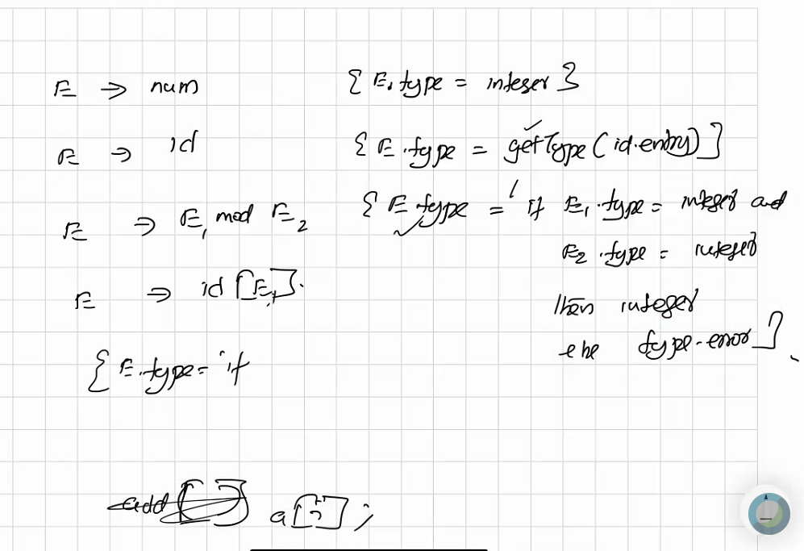

#### Lecture 29: Type Checking

#### 11 Feb 2021

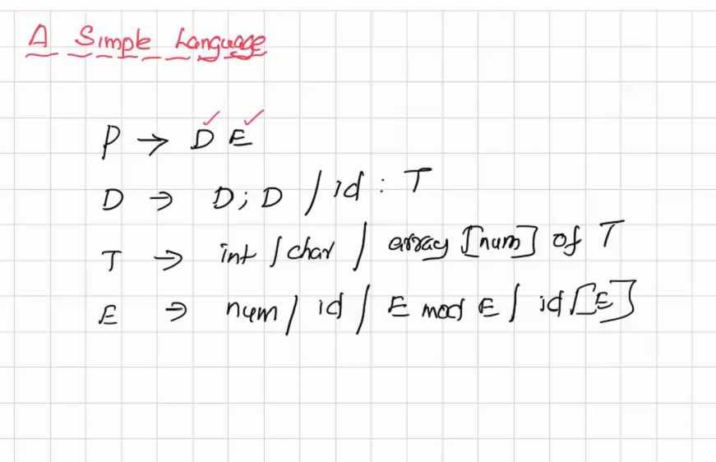

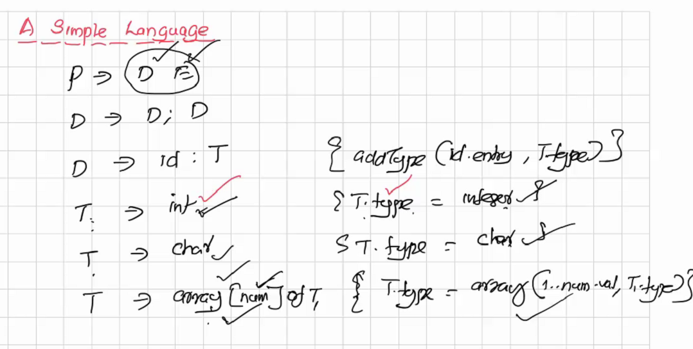

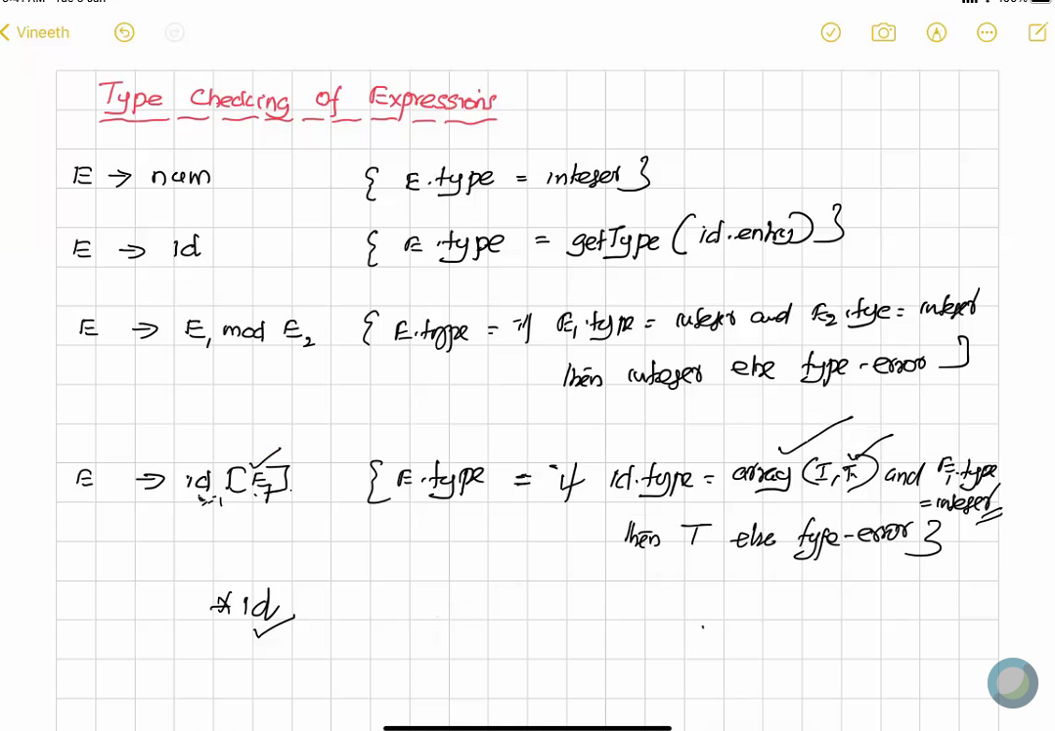

Out of bounds checked by array(I, T)

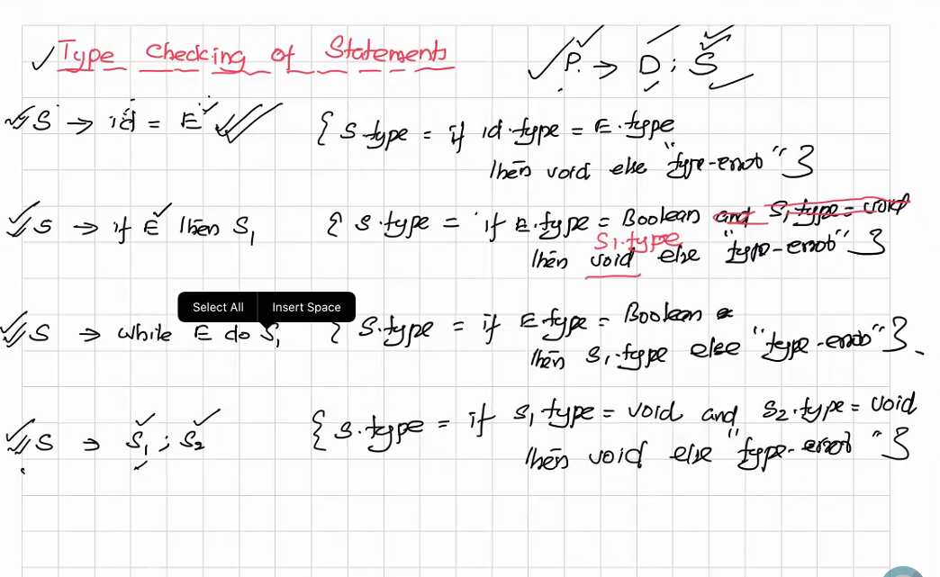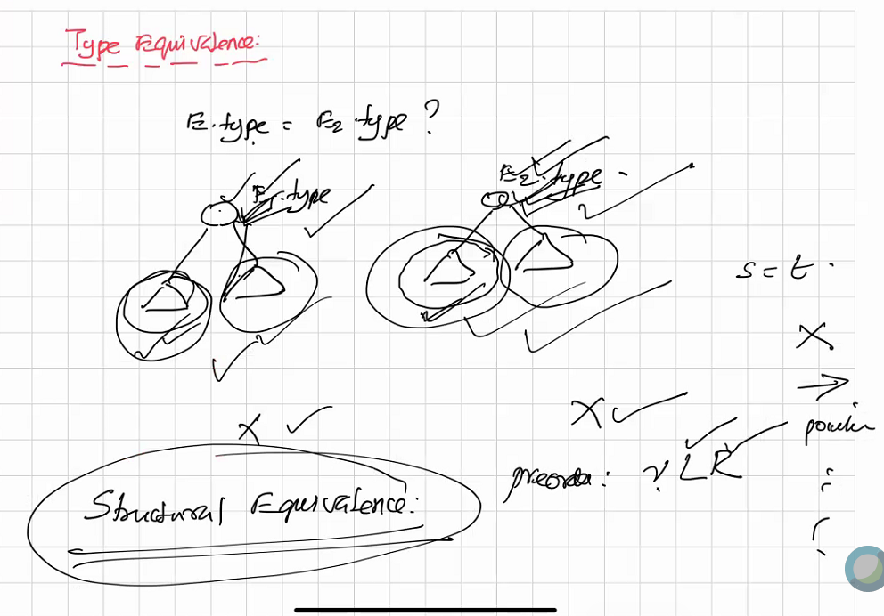

Name equivalence also exists to check if the type defined for 2 diff expressions are of the same name.

Sometimes this is converted to structural equivalence

WRITE IN THE NEW NOTES